


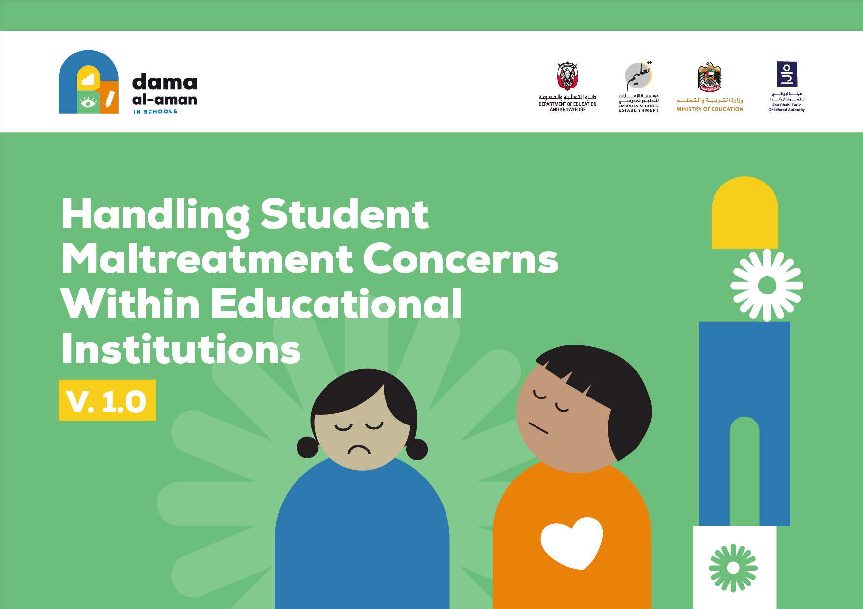

Table of Content

Introduction 5
1.1 Objectives of student maltreatment concern handling within schools 5
1.2 Who is this document for 6
1.3 Guiding principles 6
1.4 Benefits of establishing procedures for concern handling within educational institutions 7
1.5 Glossary of terms used in the document 8
2 Operational definitions of student maltreatment 11
2.1 Physical abuse definition 11
2.2 Sexual abuse definition 12
2.3 Emotional and psychological abuse definition 13
2.4 Neglect definition 14
2.5 Exploitation 14
2.6 Bullying/cyberbullying definition 16
3 Signs, symptoms, and behaviors indicative of student maltreatment 17
3.1 Signs of physical abuse 17
3.2 Signs of sexual abuse 18
3.3 Signs of emotional/psychological abuse 19
3.4 Signs of neglect 20
3.5 Signs of exploitation 21
3.6 Signs of bullying/cyberbullying 23
4 Legal framework 24
4.1 What is mandated reporting of child maltreatment (according to the Wadeema Law – UAE Child Rights Law) 24
4.2 What are the implications of not reporting (according to the Wadeema Law) 26
4.3 Can a report be made anonymously (according to the Wadeema Law) 26
5 Roles and responsibilities in handling concerns of student maltreatment in schools 26
6 How educational institutions should notify the authorities in case of student maltreatment suspicion 33
7 How should maltreatment concerns detected/disclosed in educational institutions be managed 36
8 Framework for the initial safety and risk assessment and referrals 39
8.1 Objectives of the initial safety and risk assessment 39
8.2 The levels of risks 40
8.3 The assessment framework 41
8.4 Determining the overall risk level and the subsequent procedures required 46
9 Examples of procedures for concerns detected/disclosed in educational institutions by category of reporter 47
9.1 Disclosure from the concerned child 47
9.2 Disclosure from parents 47
9.3 Disclosure from Students 48
9.4 Concerns identified by teachers 48
9.5 Concerns identified by other school staff (e.g., nurse) 49
9.6 Concerns identified by auxiliary school staff (e.g., bus driver) 49
10 Examples of procedures for concerns that would be managed internally by the school 49
11 How should concerns be referred to the Child Protection Unit? 50
11.1 Who to contact for notification of concerns of student maltreatment 50
11.2 If the student requires medical support, what should be done 51
11.3 What forms to fill 51
11.4 What happens after the concern is reported to the Family Care Authority 51
12 How should concerns about school personnel be managed 52
13 Engagement model with the student and family 52
13.1 Dealing with disclosures 52
13.2 How to engage with the student before, during and after notifying a concern 53
13.3 How to engage with the family before, during and after notifying a concern 54
14 Confidentiality and information sharing 54
15 Training requirements 55
16 Forms needed 56

Acronyms

ADEK: Abu Dhabi Department of Education and Knowledge

MoE: UAE Ministry of Education

MoI: Ministry of Interior

MoI-CPC: Ministry of Interior – Child Protection Center

FCA: Family Care Authority

CPS: Child Protection Specialist

CPU: Child Protection Unit

Introduction

Objectives of handling student maltreatment concerns in schools

All children in Abu Dhabi should feel safe and protected. They have the right to be protected from harm wherever they are and protecting them is everyone’s responsibility. As children spend a considerable portion of their time in educational institutions, efforts should be invested from all relevant stakeholders to ensure children’s protection. This includes the relevant government entities (e.g., Ministry of Education (MoE and Abu Dhabi Department of Education and Knowledge (ADEK)), staff, volunteers in schools, parents, and the wider community. This also includes private organizations and NGOs, where relevant.

This document aims to provide guidelines to respond to concerns of student maltreatment within educational institutions in the Emirate of Abu Dhabi.
It showcases the steps, roles and responsibilities of all educators, non-teaching staff and contractors (or auxiliary staff) in ensuring the protection of students, as stipulated in the relevant national laws and policies.

This document aligns with the procedures defined in the below national and Abu Dhabi level documentation (part of which are referenced later in the document):
- Abu Dhabi Child Protection Policy
- MoE National Policy for Bullying Prevention in Educational Institutions
- MoE National Policy on Child Protection in Educational Institutions in the United Arab Emirates
- Abu Dhabi Student Protection Policy for Educational Institutions
- ADEK Private Schools Policy and Guidance Manual
- ADEK Private Schools Reopening Policies (2021)

A complete list of documents references is included at the end of the document.

This document should also be considered jointly with the Abu Dhabi Student Protection Policy developed for educational institutions.

Who is this document for

This document applies to and should be made available to all teaching staff and non-teaching staff (including social workers, counselors, nurses, child protection specialists, child protection coordinators, MoE, and ADEK CPU staff), admin staff, contractors/auxiliary staff (including cleaners, bus drivers, canteen workers, janitors, etc.) and volunteers. An introduction to Abu Dhabi child protection practices should be made available to parents/guardians and students.

Guiding principles

Best interest of the student: The best interests of the student must be a priority in all actions taken in respect to the care and protection of students (0-18 years). All school staff must constantly evaluate the positive and negative consequences of actions and discuss these with the students and their parents/guardians when taking decisions. All actions should ensure that the child’s rights to safety and their on-going development should never be compromised.

Non-Discrimination: School staff must ensure that all students receive appropriate care and support in their best interests, regardless of any individual characteristics, gender, age, socio-economic background, race, religion, ethnicity, or disability.

Student participation: Students have the right to express opinions about their experiences and to participate in relevant decisions that might generally affect their lives. School staff are responsible for communicating to students their right to participate – including the right not to answer questions that make them feel uncomfortable – and supporting them to claim this right throughout the student maltreatment concern handling process.

Confidentiality: All information should ensure the child and family's privacy and confidentiality (both the family’s ’s and the suspect’s r’s), documentation and storage of all information should be maintained within a secure system and information should primarily be shared only with, child protection officials, who have been assigned to follow-up on the concern. When information is shared, it should be on a need-to-know basis and limited only to the information necessary to enable better protection of the child/perpetrator.

Mandatory and timely reporting: All school staff are required (per Federal Law No. 3 of 2016 on Child Rights) to adopt the principle of mandatory and timely reporting to the relevant authority in case of detection, suspicion or occurrence of student maltreatment that was identified within the educational institution’s premises, its surroundings, its facilities, transport buses or during external activities organized by the educational institution. (The process of handling student maltreatment concerns is discussed in sections 5-8 of this document.)

Benefits of establishing procedures for handling concerns within educational institutions

The child protection system developed for Abu Dhabi provides, guidance and preventive programs for the handling of student maltreatment cases.

The student protection policy implemented within educational institutions should be aligned to procedures described in this document.

A student protection policy has also been developed in educational institutions in Abu Dhabi.

The student protection policy within educational institutions must be consistent with the procedures described in this document.

In addition, all schools should implement child protection guidelines and practices, and staff training should be provided.

The procedures in this document result in multiple benefits for the various target groups, highlighted below:

Benefits for students:
- Informed about their rights, and about safety and protection measures in general
- Ensuring their participation
- Access to the support needed (incl. counselling and guidance services if needed)

Benefits for parents:
- Greater knowledge of student protection mechanisms within schools
- Greater trust in schools
- Referring to relevant services

Benefits for school staff (incl. auxiliary staff and volunteers):
- Early identification of students at risk of harm or at risk of being maltreated in schools
- Responding quickly to student maltreatment concerns and referring students to relevant authorities (e.g., the Police, hospitals, etc.)

In addition, this document leads to benefits for MoE and ADEK:
- Supporting the roles and responsibilities of MoE and ADEK and for educational institutions to provide protection and a safe learning environment for students, free from harm and violence
- Ensuring the alignment and consistency of handling student maltreatment concerns in all schools in Abu Dhabi
- Ensuring the alignment and coordination within the overall child protection system in the Emirate of Abu Dhabi

Glossary of terms used in the document

Below are the definitions of key terms used across this document:
- Allegation of student maltreatment: Accusation made against a person of having maltreated a student. The accusation can be made by the student or by another person who has reason to suspect maltreatment
- Auxiliary staff: Contractors and volunteers working in the school (e.g., bus drivers, cleaners, canteen workers, janitors, etc.)
- Child: Any resident of the UAE under 18 years of age
- Child protection: All measures, steps and actions that must be taken to prevent, protect and support students from risks that may cause harm or injury while they are under the supervision of the educational institution, travelling to and from the educational institution using institutional transport, and moving between, waiting for and taking part in all activities organized by the educational institution inside or outside its premises.
- Child Protection Coordinator (CPC): Appointed staff member at the school/nursery who is professionally relevant, trained and equipped with skills to act upon child protection concerns that arise within their educational institution and is the key contact for staff and authorities where a concern is identified within the educational institution. The CPC should also be the point of contact for the educational institution to respond to emergency cases, communicate with the CPU and other entities involved, liaise with parents, and provide ongoing support to the child.
- Child Protection Unit (CPU): Organizational unit at MoE and ADEK aiming at developing and implementing student protection measures for educational institutions in the Emirate of Abu Dhabi in line with Federal Law No. (3) of 2016 Concerning Child Rights and its bylaws. The Units are responsible for receiving and assessing student maltreatment concerns, in line with the procedures detailed in this document, along with the Student Protection Policy for Educational Institutions. The MoE CPU handles concerns related to KGs and public schools in Abu Dhabi, whereas the ADEK-CPU would be primarily responsible for handling concerns occurring within or being disclosed to the private schools, charter schools and nurseries in Abu Dhabi (in the cases where the CPUs are not handling the cases pertaining to these educational institutions, they would be reported)
- Child Protection Specialist (CPS): The person authorized by MoE, ADEK, the Abu Dhabi Judicial Department and the Ministry of Community Development to preserve and protect the rights of the child, each within its specialization, in accordance with Federal Law No. 3 of 2016 on Child Rights (commonly known as Wadeema’s Law), its bylaws and Cabinet Resolution No. 52 of 2018 Governing the Executive Regulations of Federal Law No. 3 of 2016 on Child Rights
- Child Protection System: Set of coordinated mechanisms between various organizations to ensure the prevention and appropriate response to concerns of child maltreatment. The education sector has a key role in student protection
- Child Protection Team: Team led by the Child Protection Coordinator, and should include a deputy coordinator, a counselor, and other relevant staff member, forming the case management unit for all cases that are to be resolved in school. In educational institutions where such a team cannot be formed (e.g., due to resource limitation), the Child Protection Coordinator would be responsible for the in-school case management, and a representative should always be nominated in case the Child Protection Coordinator is not available/unable to perform their duties
- Chronic Absenteeism: Student with (20) or more excused or unexcused absences within the academic year
- Consent: Written consent regarding the services to be provided to the student who is 13 years old. All children, regardless of age, should be informed of the steps that will be taken, and their opinions should be heard regarding the family and/or child protection specialist will make the final decision regarding the types of services required. If the family or student refuses the services or procedures, necessary actions should be taken to refer the matter to the public prosecution
- Corporal punishment: The act of inflicting physical pain to a child for the purpose of exercising power or control that causes intentional physical pain or humiliation in order to inflict pain or discomfort even minimal to discipline a child.
- Educational institution: Any entity enrolling children across educational stages – including KGs, public schools, nurseries, and private/charter schools – that is under the supervision of the MoE and/or ADEK
- Educator: Anyone working in the education sector, whether in schools or at MoE and ADEK (e.g., principal, vice principal, teachers, teaching assistants, librarians, lab technicians and other specialists)
- Family Care Authority (FCA): The Abu Dhabi Authority responsible for child protection case management
- Handling student maltreatment concerns: Process of organizing and carrying out work to respond to students’ protection concerns in an appropriate, systematic, and timely manner. This can be completed through direct support from the educational institution (such as counseling in school) and/or referrals to other concerned entities (for more serious or complex cases of maltreatment)
- Identify/detect cases of maltreatment: Recognition of signs/risk of suspected student maltreatment at occurrence through witnessing, and/or disclosures from the maltreated child, other children or, parents/guardians, school staff or any other person in or outside of schools
- Initial safety and risk assessment: Analysis of information obtained from a disclosure or report to evaluate the severity of a case, likelihood of harm and the impact on a child’s development, then identify whether there is a need for further investigation by the Police, or for a referral to the FCA.
- Visitor: an individual visiting the educational institution on a temporary basis to interact with students (e.g., a speaker, career fair representative, etc.)
- Mandated reporter: A person who is required by law (under Article 42 of Federal Law No. 3 of 2016 on Child Rights, commonly known as Wadeema’s Law) to report student maltreatment concerns related to students to the Child Protection Specialist. This includes the educators in educational institutions, or any adult on institution premises or outside the institution premises from which the student requests assistance in notifying the authorities (e.g., the Police, MoI-CPC, MoE and ADEK) about his/her suffering or any other student’s suffering.
- Notify: Informing the Child Protection Coordinator or relevant entities (e.g., child protection hotline at the Ministry of Interior, i.e., MoI-CPC), Police, MoE, ADEK or the Child Center at FCA) when student maltreatment is suspected
- Parent/guardian/caregiver: is the person legally liable for a child or entrusted with their care, defined as the custodian of the child as per the Federal Decree Law No. 3 of 2016 Concerning Child Rights. (Wadeema’s Law).
- Peer-to-peer maltreatment: Harmful student-to-student behavior that could be included in the definition of student maltreatment (e.g., harmful student sexual behavior)
- Suspicion of student maltreatment: Suspicion that maltreatment has occurred to objective justifications; however, without complete certainty (includes witnessing the maltreatment themselves, hearing from the student that maltreatment occurred, receiving information from another source, etc.)
- Report: Documenting a suspicion of student maltreatment by the Child Protection Specialist at MoE, ADEK or FCA, based on unified parameters for the initial assessment, and officially communicating it to the relevant authorities
- Risk of student harm: Harm which has not yet occurred but is likely to in the future, given risk factors identified in the present
- Safety Concern Form: Template form to be filled by a mandated reporter and/or the Child Protection Coordinator within the educational institutions, to report any disclosure and/or suspected case of maltreatment
- Safeguarding: Protecting students from all risk of harm, including maltreatment and other types of risks that impact their overall health and development, wellbeing, and safety.
- Supervision: The state of being responsible, having the duty of care, and keeping watch over an individual in the interest of their and others’ security while utilizing its systems and taking part in all activities organized by the school, inside or outside its premises, including travelling to and from the school using its transportation, and moving between and waiting for activities.
- Student: A citizen or resident who is enrolled in an educational institution in Abu Dhabi.
- Staff: an individual employed by a school on a remunerated contractual basis regardless of employment mode (internal, external/third-party, etc.).
- Student maltreatment: Is synonymous to child maltreatment, which refers to abuse (physical, emotional, and sexual), and includes neglect, exploitation, bullying, and cyberbullying of a student.
- Student protection: Is synonymous to child protection, which is defined as all measures, steps and procedures that must be taken to prevent, protect and support students from risks that may cause harm or injury whilst they are under the supervision of the educational institution.
- Volunteer: An individual engaged by an educational institution on a non-remunerated basis to interact with students (e.g., parent chaperones, etc.).

Operational definitions of student maltreatment

Physical abuse definition

An intentional physical act that has a likelihood of resulting in, or poses a threat of resulting in immediate and/or long-term physical injury or harm on the student’s health, or opposes risk to the child’s survival, and development

Examples include:
- Hitting the student with hand, fist, or other object such as wooden spoon, shoes, belt, etc.
- Kicking or biting the student in sensitive areas of the body such as the head, face, ears, stomach and/or genitals
- Causing bruises, bleeding, or fractures of bones
- Pulling the arm or the hair of the student intentionally to cause harm
- Shaking or pushing the student violently, or throwing the student around causing injuries
- Tying, caging, or chaining the child
- Fabricating, intentionally exaggerating in illness that may result in harmful medical evaluation or treatment of the student
- Stabbing, choking, burning, drowning, electrocuting, poisoning, or giving the child-controlled substances not prescribed for the student by a medical practitioner

Corporal punishment is considered a form of physical abuse.

A physical act carried out by a person in power and authority against a student, that deliberately physically hurts and humiliates the student to cause pain or discomfort, even minimal as a method of discipline.

Examples include:
- Smacking, slapping, spanking the student with hand or object such as a shoe, belt, “egal”, wooden spoon or paddle
- Pinching, biting, or pulling the student’s hair
- Kicking, throwing, pushing, or shaking the student
- Forcing the student to stand in an unpleasant position or under the sun, or in positions that cause them physical harm and pain
- Forcing the student to digest hot spices, washing their mouth out with soap
- Inflicting burns or cuts to the student

Sexual abuse definition

It is the coercion, attraction, or involvement of a student in sexual activities that they may or may not fully comprehend, or that violates the laws or social taboos of society. Activity could also include practices that do not involve any physical contact, such as involving students in watching or producing pornographic material, watching sexual practices, or encouraging students to behave in inappropriate sexual ways. Student sexual abuse o occurs between an adult and a student, or between students, who by age or development is in a relationship of responsibility, trust, or power. The intent of the activity is to gratify or satisfy the needs of the perpetrator

Examples include:
- Sexting or sharing with the child sexual images or materials that include sexually explicit language
- Grooming the child through verbal, written or physical behavior for future sexual abuse
- Blackmail the child to behave in a sexually inappropriate manner; or to expose themselves indecently for the purpose of the perpetrator’s sexual gratification; or for purposes of shaming, humiliating, or exerting control over the student
- Fondling and kissing the child inappropriately, or using body weight to force an act for the purpose of sexual gratification of the perpetrator, or for purposes of shaming, humiliating, or exerting control over the child
- Intentional masturbation of the perpetrator or exposure of the perpetrator’s genitals in the presence of the child
- Rubbing and touching the child inside or over clothing
- Penetration or contact between the genitals of the child and the genitals of the perpetrator
- Rape

Emotional and psychological abuse definition

An act, whether consistent or inconsistent, offensive to the child by making him/her feel unloved, worthless and of no value and integrity, affecting the child’s positive mental and emotional development

Examples include:
- Insulting, aggressing, humiliating, shaming, or intimidating the child, or conveying to a student that he/she is worthless, unloved, or unwanted
- Frightening or threatening the child to cause physical harm to the point of anxiety
- Blaming the child and making him/her a scapegoat to the point of negatively impacting the student’s self-esteem and self-worth
- Imposing inappropriate expectations on the child that are beyond his/her developmental capability, thus causing serious emotional discomfort
- Discriminating negatively between the child and others with the purpose of degrading them
- Not providing an opportunity for the child to express views or deliberately silencing him/her, or gagging the child’s mouth
- Restricting the student’s movement, or confining/locking the child in a small space
- Forcing the child to witness domestic violence

Neglect definition

Failure of a parent or caregiver to provide the basic needs and rights of a child to protect their life, physical safety, development, psychological, mental, moral integrity and wellbeing, which may lead to developmental delays in the context of the resources reasonably available to the family and/or caregiver and causes or has a high probability of significant harm to the child’s health or physical, social, educational, mental, spiritual or moral safety

Examples include:
- Failing to protect the child from abandonment and maintaining regular contact with the child.
- Failing to provide the minimum required emotional support and love to the child to ensure their sound development and wellbeing
- Failing to meet the student's basic needs including ensuring an adequate level of food, housing, clothing, and basic medical services (incl. any specialized medical care the child may need, e.g., for asthma or diabetes) and vaccinations
- Failing to enroll the child in school, or not sending the child to the school regularly
- Permitting the child to live under conditions imposes risk to their wellbeing such as substance use by parents/caregivers, exposure of the student to family violence or other violent events
- Leaving the child at home without proper supervision, or leaving them in the car in a manner that is inappropriate for the child’s age, level of development, cognitive abilities and/or verbal abilities
- Leaving the student with an adult who is not a family member, and who is not related to the student in any way
- Allowing the child to use digital devices for an excessively long period of time daily
- Allowing the child to consume alcohol or drugs, or drink harmful liquids stored at home, or having burning tools such as lighter or matches accessible to the child
- Allowing children to drive unlicensed

Exploitation

Use of the student in work or other activities for the benefit of others. This includes, but is not limited to, student labor and exploitation of students in prostitution or involvement of the student in gangs, militia, or military. These activities are to the detriment of the student’s physical or mental health, education, moral or social development.

Sexual exploitation

Form of sexual abuse where there is an abuse of power by a youth, adult or group who may coerce, manipulate, or deceive a student into sexual activity by physical contact and/or use of technology for monetary, social, or political profits.

Examples include:
- Notifying the student that they are in debt in exchange of gifts or attention received
- Uploading or purchasing sexual abuse material of students online
- Introducing the student to a party-based lifestyle with sexual acts, drugs, alcohol, or deceiving and coercing, to sexually groom a child
- Sharing or threatening to share indecent images, films, or drawings, engaging the student in pornographic material, and blackmailing them
- Involving a student in prostitution, sexual slavery, and sex tourism, or coercing the student to participate in sexual acts with others, or using physical violence to defeat the student’s will (such as gang-rape)

Economic exploitation

Use of a student who is below the minimum age of labor in the workplace or related activities for the benefit of others through the production, distribution, and consumption of goods or of a particular service delivered by the student.

Examples include:
- Selling and trafficking a student
- Engaging students in armed conflict
- Engaging a student in begging, or selling and distributing narcotic drugs for use in other criminal acts
- Employing a student in domestic services, working in shops, working in farms

Bullying/cyberbullying definition

Bullying

Repeated physical, psychological, social, or verbal aggression exercised by students who feel they are in a position of power against other students who are perceived weaker or powerless, to achieve specific gains or draw attention, in a way that hurts the student physically and/or emotionally; bullying can be committed by groups or individuals, in online (cyberbullying) or offline settings.

Examples include:
- Giving the student menacing stares or hand signs, chasing the student, physically threatening the student, or threating to harm their family, or exercising physical violence against the student (beating and kicking)
- Damaging belongings, taking the student’s food, or intentionally destroying the student’s medicine
- Ignoring the student, excluding the student intentionally from a group or forming coalitions against him/her
- Name-calling, mocking, teasing, constantly criticizing or undermining the student

Bullying in schools refers to any act of physical, social, or emotional abuse perpetrated by one or more students against another student.

Cyberbullying

Bullying that takes place online using electronic devices such as computers, tablets, and smart phones typically by sharing/sending true or false comments or pictures/videos. Online bullying can follow the bullied student wherever they go and usually spreads beyond the initial perpetrator as it has a wider reach than bullying in the real world, via social networks and mobile phones.

Examples include:
- Impersonating the student on the internet and posting content on their behalf, to embarrass or cause trouble to them
- Sending the student threatening or abusive text messages or messages on social networks (incl. grooming via online gaming)
- Creating and posting inappropriate and embarrassing photos and videos, and shaming the student online
- Setting up hate sites or groups about a student, and voting for or against a student in abusive polls

Signs, symptoms, and behaviors indicative of student maltreatment
Selected examples of physical, emotional, and social behaviors of the student that are indicative of maltreatment are highlighted below.

Signs of physical abuse

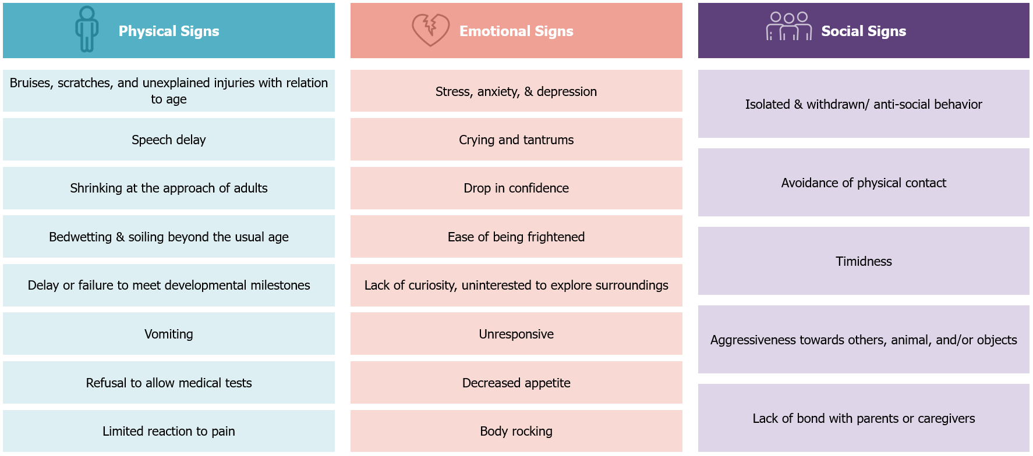

Signs of sexual abuse

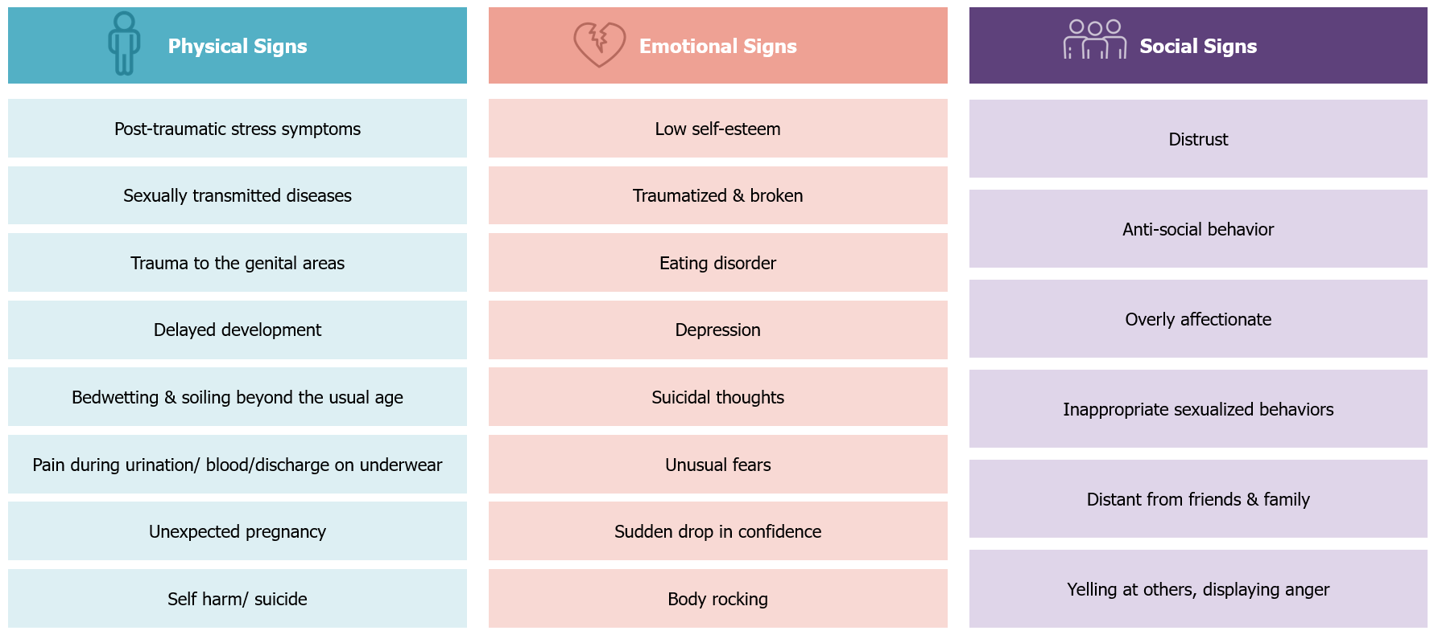

Signs of emotional/psychological abuse

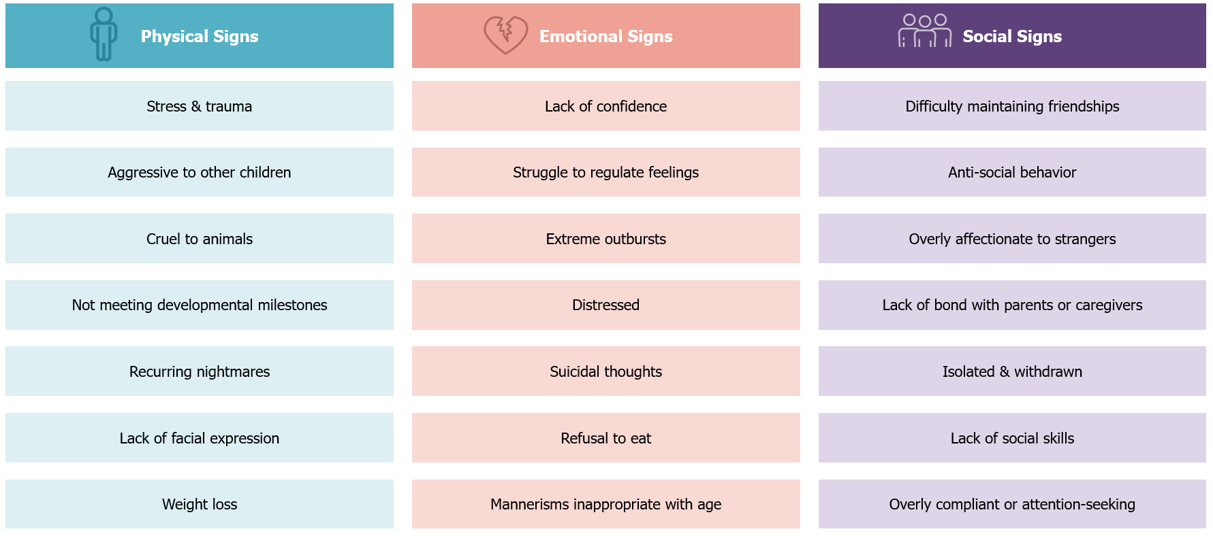

Signs of neglect

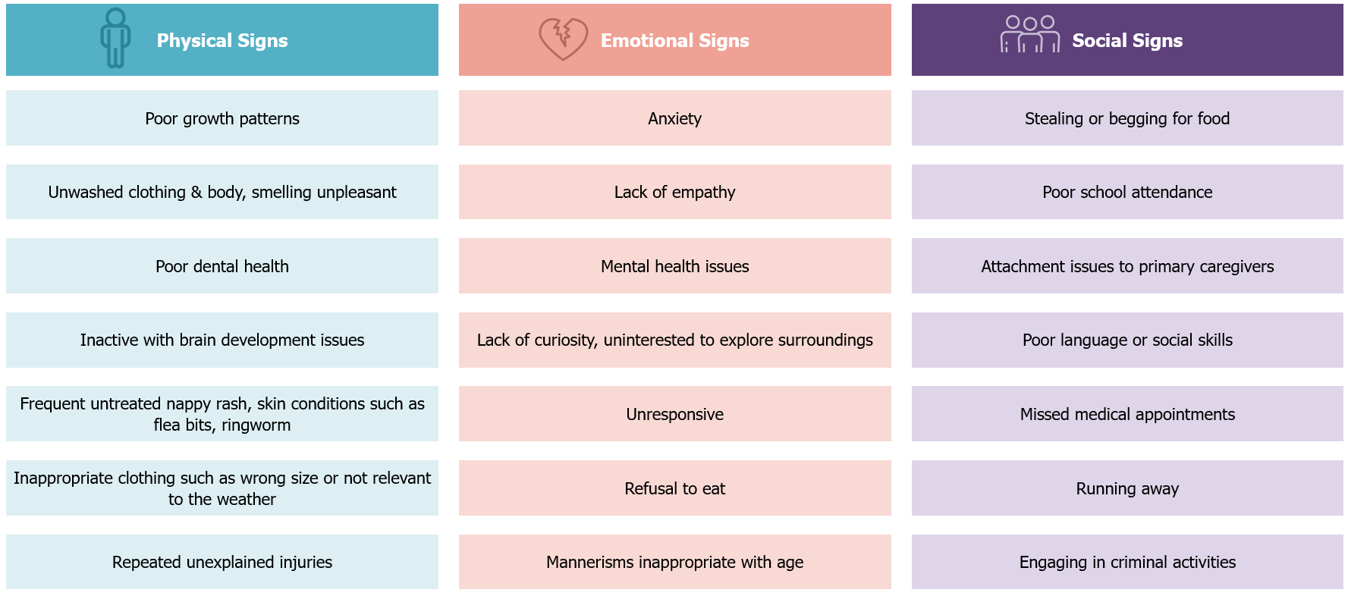

Signs of exploitation

Sexual exploitation

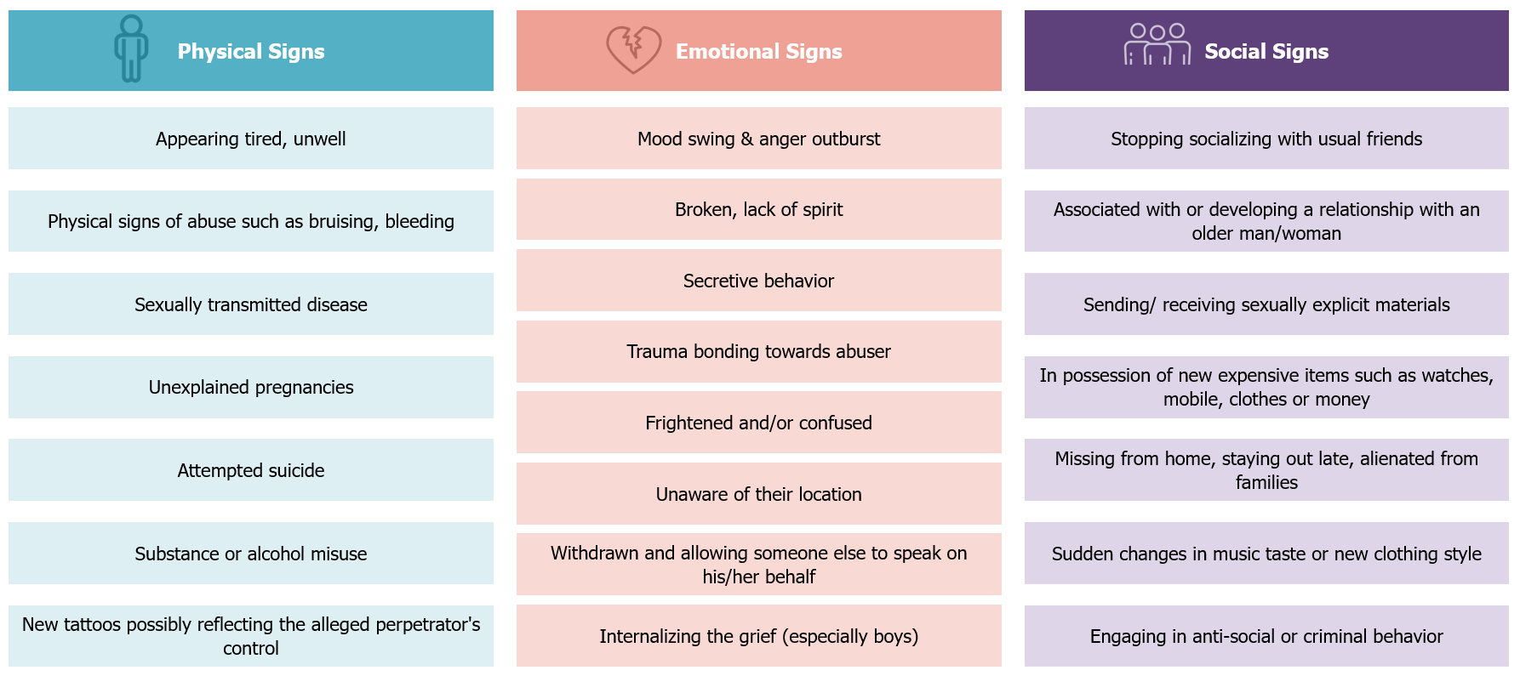

Economic exploitation

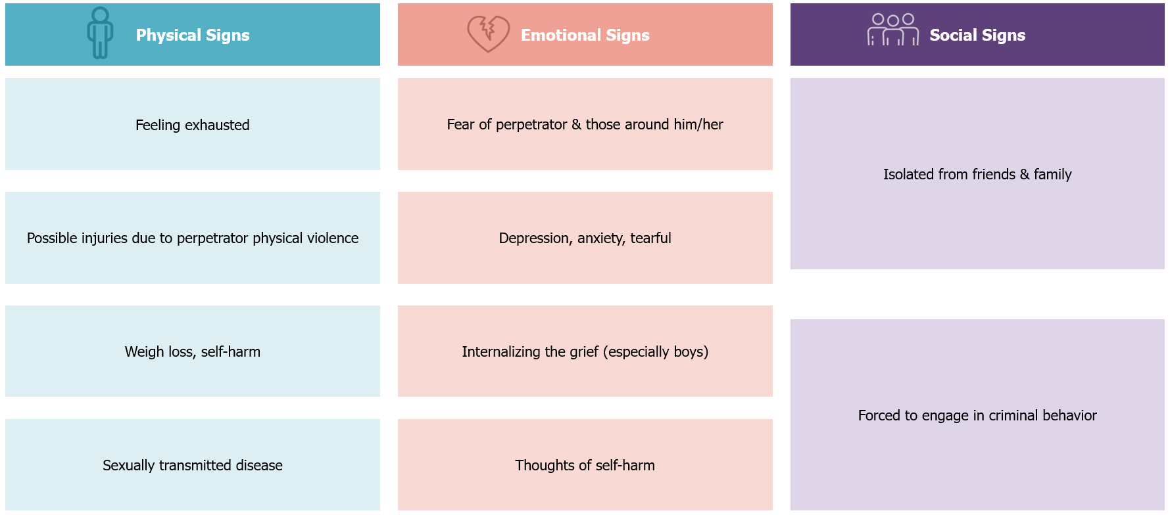

Signs of bullying/cyberbullying

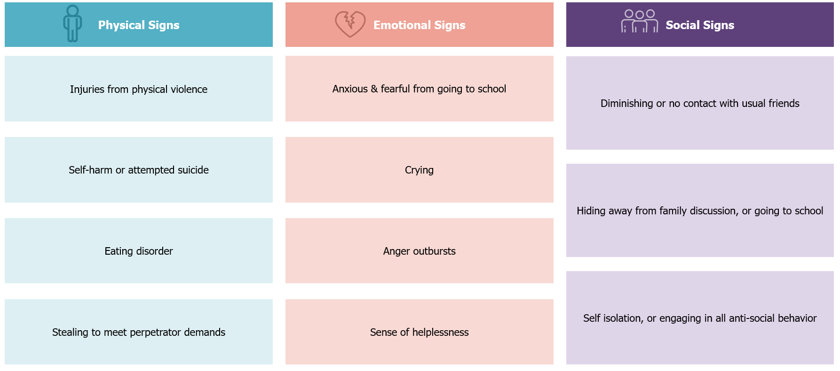

Legal framework

What is mandated reporting of child maltreatment (according to the Wadeema Law – UAE Child Rights Law)

Article 42 of Federal Law No. 3 of 2016 Concerning Child Rights (i.e., referred to henceforth as the “Wadeema’s Law”) states that Every person shall notify the child protection specialist or child protection units in case of anything that threatens the child's physical, psychological, moral, mental integrity, or health.
The notification shall be mandatory for the educators, physicians, social specialists, or others entrusted with the protection, care, or education of the child.

The Law makes it also mandatory to report maltreatment in case the child asks for someone’s assistance.
Article 43 states that Every person who reaches the age of majority shall assist any child who asks him/her to notify the competent authorities or concerned entities about their suffering, the suffering of any of their siblings or any other child in one of the cases set forth in Article 33 hereof.

As a result, the following non-exhaustive categories of professions are considered mandated reporters:
- Teaching staff, non-teaching staff, admin staff, contractors/auxiliary staff and other employees in public and private schools, charter schools and nurseries
- Administrators or employees of licensed community care or student daycare facilities
- Administrators or employees of day camps, student and youth centers, or student and youth recreation programs
- Social workers and social service workers within social institutions
- Employees at social assistance, social protection and family and marital counseling programs (incl. family and marriage therapists)
- Domestic workers with a caregiving responsibility
- Foster parents, alternative family members and personnel of residential care facilities for students
- Police officers, and other employees in Police departments
- Probation officers and parole officers
- Prosecutors and judges
- Forensic doctors
- Physicians, surgeons, psychiatrists, psychologists, dentists, residents, interns, licensed nurses, dental hygienists or social workers and other employees within health facilities
- Alcohol and drug counselors
- Student visitation monitors (sheltering facilities, courts)
- Religious service providers and employees of religious centers and/or services
- Athletic coaches and administrators, or other employees of out of school programs and sports clubs
- Commercial film and photographic print or image processors, computer technicians
- Security employees
- Volunteers/interns tasked with assisting the above-mentioned professions
- Any other persons who are directly/indirectly affiliated in providing students with direct services, programs, and/or activities

In addition, Article 29 states that the telecommunications companies and internet service providers shall notify the competent authorities, or the concerned entities of any child pornography materials being circulated through the social media sites and on the Internet and shall provide necessary information and data on the persons, entities or sites that circulate such material or intend to mislead the children.

As such, the following categories of professions are also considered mandatory reporters:
- Telecommunications
- Internet services
- Photography/filmography

A report is required by mandated reporters when the following circumstances apply:
- A mandated reporter, in his/her professional capacity or within the scope of his/her employment, has knowledge of or observes a student whom the reporter knows or reasonably suspects of being maltreated
- A person is called upon to provide aid to any student who is suffering from an injury that reasonably appears to have been caused by maltreatment
- Individuals who have knowledge of or observe any film, photograph, videotape, negative or slide depicting a student under age 18 engaged in an act of sexual conduct
- Technicians/telecommunications employees have knowledge of or observe, within the scope of their professional capacity or employment, any representation of information, data or an image, including, but not limited to, any computer hardware, software, file, floppy disk, data storage medium, CD-ROM, computer-generated equipment or computer-generated image that is retrievable in perceivable form and that is intentionally saved, transmitted or organized on an electronic medium, depicting a student under age 18 engaged in an act of violation of children’s rights

What are the implications of not reporting (according to the Wadeema Law)

Article 60 of the same Law states that Whoever violates the provisions of Clause 2 of Article (42) of this Law shall be punished by imprisonment or a fine not less than AED 5,000 (five thousand).

Not reporting maltreatment when asked by a child is also punishable by Law. Article 61 states Shall be punished by a fine not less than AED (5,000) five thousand and not exceeding AED (50,000) fifty thousand, whoever violates the provisions of Article (43) hereof.

Can a report be made anonymously (according to the Wadeema Law)

Reporting a child maltreatment concern can be made anonymously. Article 44 of the Wadeema Law stipulates that the identity of the reporter shall only be disclosed with his consent, and it shall be forbidden to disclose the identity of all the parties of the incident and the witnesses in the cases of child assault or abuse, upon using the information in the analyses or media reports or upon publishing all that may reveal his identity. While Article 45 ensures that the concerned and competent entities shall provide protection to the witnesses at all stages of the criminal proceedings.

Roles and responsibilities in handling concerns of student maltreatment in schools

Ministry of Education:
Article 5 of the executive regulations of the Wadeema Law establishes the procedures for reporting violations of children's rights within educational institutions and outlines the Ministry's responsibilities in disseminating these procedures. It mandates that the Ministry of Education circulate reporting guidelines to all schools and educational institutions, clarifying the roles and responsibilities of staff in both public and private institutions. This includes the obligation to report any observed abuse or violence against children, as well as any suspected violations of their rights. The article also highlights the consequences of failing to report such incidents

Child Protection Unit (CPU) at the Ministry of Education:

Article 6 of the executive regulations of Wadeema’s Law requires educational institutions to consult the Child Protection Unit for reporting complaints or violations concerning child protection or educational rights. These units are available within the Ministry of Education to address concerns about student maltreatment in public schools across the UAE, including Abu Dhabi. Similarly, ADEK addresses concerns about student maltreatment in private schools, charters schools, and nurseries in Abu Dhabi. The CPU is the protective mechanism for all schools in the Emirate of Abu Dhabi and aims at developing and implementing student protection measures.

The previous article outlines the roles, responsibilities, and specialties of the Child Protection Unit within the Ministry of Education in intervening with abused children, as detailed below:

Upon assessing the situation, the Child Protection Unit will take the following actions:
- Notify the police in cases that constitute a criminal offense, such as imminent danger or severe abuse.
- Admit the child for medical treatment and obtain a medical report if necessary.
- Refer the child who has experienced abuse to appropriate rehabilitation programs as needed.
- Develop plans, solutions, and suggestions to minimize the effects of the abuse in coordination with the guardian/parent or caregiver.

In addition to the other responsibilities outlined in Article 7 of the executive regulations, which assigns various duties and functions to the Child Protection Units:
- Develop, monitor, and enforce student protection policies and safeguarding measures.
- Support educational institutions in formulating their own student protection policies when needed.
- Establish standards for developing suitable intervention plans in educational institutions.
- Ensure student protection standards are integrated in school inspection frameworks and provide the necessary support to institutions that do not meet standards
- Collaborate with stakeholders to design and implement student maltreatment prevention programs.
- Provide guidance to reporters and redirect them to the safety concern portal if they are reporting a child maltreatment concern.
- Receive reports of any violations of children's rights as stipulated by enforced legislations in the country.
- Promote a culture focused on child rights to limit violations that may occur to children by all possible means.
- Contribute to the reconciliation between the child and his/her parents, caregivers, or any other party, in which there is no violations of the law.
- Follow-up and support investigations into crimes happening against the child if necessary.
- Receive and review reports of concerns that threaten the child or his/her physical, psychological, moral or mental safety or safety, including student maltreatment.
- Implement appropriate preventive measures to protect the child subject to the report.
- Develop suitable preventive plans within the jurisdiction of educational entities, providing consultation and support to families and children subjected to maltreatment, or violence, or exploitation and introducing them to effective educational foundations for dealing with children
- Coordinate with relevant entities to provide psychological, social and health treatment for children who have been exposed to anything that threatens the child or threatens his/her physical, psychological, moral or mental safety or safety, including maltreatment.
- Follow-up with families and children throughout the protection process, provide them with the necessary requirements, assess their conditions to determine the progress of their case, and provide them with necessary recommendations in collaboration with the FCA.
- Coordinate with relevant entities and specialized departments to search and investigate missing children from their families and residences.
- Take the necessary measure in cases of suspected threats to the child or threat to his/her physical, psychological, moral or mental safety, including the maltreatment of a student by an employee of the educational institution.
- Activate bullying prevention programs and activate bullying prevention policy in the school environment.
- Collaborate with CPS in the educational institution to follow-up on cases handled within the public schools.
- Supervise the management of cases that are the responsibility of CPS in the institution.
- Collaborate with relevant entities and facilitate information sharing related to the educational institution for the purpose of conducting comprehensive assessments and/or investigations (in the best interests of the student and in line with the legal framework) of suspected cases of threat to the child or threat to his/her physical, psychological, moral or mental safety, including student maltreatment.
- Collaborate with the FCA to follow-up on the management of cases referred to the authority.
- Document all reports and/or communications in confidential records that are accessible only to child protection professionals or the relevant authority, where necessary and based on approved information sharing protocols.
- Participate in Family and Child Protection Committee meetings to provide support in complex cases.
- Ensure adopting safety practices in schools (including school transportation, e.g., buses, field trips, and extracurricular activities).

The main roles and responsibilities of child protection within ADEK include the following:
- Develop, monitor, and enforce student protection policies, procedures, and safeguarding measures.
- Support educational institutions in formulating their own student protection policies as needed.
- Ensure student protection standards are integrated in school inspection frameworks and provide the necessary support to institutions that do not meet standards
- Collaborate with relevant entities on the design and implementation of maltreatment prevention programs.
- Receive and review reports of concerns that threaten the child or threaten his/her physical, psychological, moral or mental safety or safety, including student maltreatment.
- Implement appropriate preventive measures to protect the child subject to the report.
- Develop suitable preventive plans within the jurisdiction of educational entities, providing consultation and support to families and children subjected to maltreatment, or violence, or exploitation and introducing them to effective educational foundations for dealing with children.
- Coordinate with the relevant entities to provide psychological, social and health treatment for children who have been exposed to what threatens the child or threatens his/her physical, psychological, moral or mental safety or safety, including maltreatment.
- Follow-up with families and children throughout the protection process, provide them with the necessary requirements, assess their conditions to determine the progress of their case, and provide them with necessary recommendations in collaboration with the FCA.
- Coordinate with relevant entities and specialized departments to search and investigate missing children from their families and residences.
- Take the necessary measure in cases of suspected threats to the child or threat to his/her physical, psychological, moral or mental safety, including the maltreatment of a student by an employee of the educational institution.
- Activate bullying prevention programs and activate bullying prevention policy in the school environment.
- Collaborate with CPS in the educational institution to follow-up on cases handled within the public schools.
- Supervise the management of cases that are the responsibility of CPS in the institution.
- Collaborate with relevant entities and facilitate information sharing related to the educational institution for the purpose of conducting comprehensive assessments and/or investigations (in the best interests of the student and in line with the legal framework) of suspected cases of threat to the child or threat to his/her physical, psychological, moral or mental safety, including student maltreatment.
- Collaborate with the FCA to follow-up on the management of cases referred to the authority.
- Document all reports and/or communications in confidential records that are accessible only to child protection professionals or the relevant authority, where necessary and based on approved information sharing protocols.
- Participate in Family and Child Protection Committee meetings to provide support in complex cases.
- Ensure adopting safety practices in schools (including school transportation, e.g., buses, field trips, and extracurricular activities).

Child Protection Specialists (CPS):

The CPSs are trained, and licensed professionals employed by the relevant CPU at MoE, and ADEK. The CPS should receive the training approved by the Ministry of Community Development, and some of them would have the judicial officer capability. CPS licenses should be issued by the Ministry of Community Development and the Abu Dhabi Judicial Department. MoE will assign each CPS with a select number of schools to monitor and provide support in addressing suspected cases of abuse.

Articles 10 and 12 of the executive regulations of Wadeema’s Law outline the roles of child protection specialists
The key roles and responsibilities assigned to child protection specialists are related to cases that occur within educational institutions and are managed by the relevant Child Protection Unit within the MoE or ADEK. These responsibilities include:
- Address cases assigned to them by the relevant CPU.
- Review the Safety Concern Form submitted by the school-based Child Protection Team/Child Protection Coordinator.
- Visit the educational institution and collect relevant information when needed (e.g., from school staff, parents/guardians, or students if they are willing to talk to the CPS).
- Remove the child from danger and place them in a safe environment, based on their assessment of the risk level
- Determine whether the case should be resolved within the educational institution or referred to the FCA and other relevant CPUs.
- Coordinate with schools and the Family Care Authority regarding students who are absent due to potential abuse or family issues.
- Coordinate and refer the cases that meet the thresholds for referral to the FCA – for those that do not meet the thresholds, coordinate with the educational institution to follow the in-school handling procedures, and provide the necessary support to the educational institution and to the student. Determine whether to address the case within the educational institution or refer it to the Family Care Authority and other relevant child protection units.
- Conduct a comprehensive social assessment within the school environment to clarify the circumstances surrounding the child and submit a report to the relevant authority along with recommendations for necessary actions.
- Integrate the child into programs and activities that promote their personal development in addressing challenges.
- Equip the child and their family with skills to tackle issues through workshops and training sessions.
- Facilitate psychological and physical rehabilitation for the child by specialists.
- Recommend family support to the Family Care Authority if it is determined that the caregiver’s shortcomings are due to the family’s social conditions.
- Develop plans and solutions to address the causes and effects of violations of the child’s rights or abuse, in coordination with the child’s guardian and, when necessary, the Family Care Authority.
- Coordinate with relevant entities to ensure the child's safety and protect their rights.
- Prepare a report for their organization to notify the public prosecution, if necessary, particularly to warn the caregiver for non-compliance with agreed recommendations, in coordination with the Family Care Authority when needed.
- Educate the child about potential risks associated with certain places or activities.
- Respond to any maltreatment related requests from the Family Care Authority for information on cases
- Provide information of the student or the incident when requested by the Family Care Authority and collaborate with the Family Care Authority on active cases
- Follow-up with the educational institution Child Protection Coordinator and/or Child Protection Teams in the educational institution
- Ensure that accurate records are maintained on individual cases and kept in a secure location within the relevant CPU. All information is considered confidential and can only be shared within the Child Protection System. (Sharing of information outside of the Child Protection System cannot be done without getting consent from the student’s parent or guardian and CPU, unless the student is in imminent danger.)
- Develop annual reports summarizing the student protection concern notifications, status and outcomes received by the relevant CPU

Educational Institution Board of Directors:
- Maintain only a high-level oversight of child protection matters in educational institutions
- Review and approve student protection policies and procedures within schools in line with laws and guidance from education regulatory bodies in the UAE
- Be involved in high profile cases of maltreatment (such as serious allegations against staff, litigations against the school; however, referral of such cases to CPU resides with the Child Protection Coordinator and/or the Child Protection Team, whereas the decision to refer the case to the FCA resides with the relevant CPU)

It is recommended that the Educational Institution Board of Directors should not be involved in the decision to report child protection concerns.

Principal (and Vice Principal):
- Verify dissemination and implementation of the student protection policy in educational institutions by all educators, school staff, parents, and students
- Ensure appropriate vetting of educators with H.R., of non-teaching staff, contractors, and volunteers prior to hiring them. Ensure that educators, non-teaching staff, contractors and volunteers are well-aware of the student protection policy and procedures
- Set procedures in addressing students missing from education
- Ensure that the Student Protection Policy in educational institutions is communicated and explained to all staff, students, and parents
- Appoint a Child Protection Coordinator (trusted person within the school, can be the school counselor, the social worker or other child specialist in the educational institution, however, the school principal should not assume the role of the Child Protection Coordinator) ensuring all school personnel, parents and students are aware of their roles and contact details (preferably posted on the school’s website – for private and charter schools and nurseries)
- Ensure ongoing training throughout the year on student protection for all educators and non-teaching staff
- Develop a documented risk plan and ensure administrative procedures are in place in case of allegations of student maltreatment against school staff
- Ensure the implementation of programs that promote student protection and adoption of prevention strategies in schools which offer support, within the possible resources of the schools, for at-risk students and their families
- Ensure prompt and direct coordination and collaboration with the relevant CPU or Abu Dhabi Police as required
- Identify, detect, and document suspected signs of maltreatment based on interactions and/or observations of students
- Ensure school Student Protection Policy and child protection guidance is adhered to, and all employees and personnel providing services for schools are adequately trained on them

Child Protection Coordinator (or any other person representing him/her):
- Identify, detect, and document, suspected signs of maltreatment based on disclosures and/or observations of students
- Receive notifications of student maltreatment concerns from educators, non-teaching staff, contractors, volunteers, visitors, parents, and students
- Review the concerns received to determine if the case should be resolved internally or reported (based on the guidelines provided in this document and guidelines provided in other ADEK, MoE documents)
- Complete the Safety Concern Form online on the digital safety concern portal for all cases of maltreatment reported in the educational institution. Once submitted, a copy of the Safety Concern Form will then automatically be shared with the FCA, the relevant CPU in educational institution (MoE CPU or ADEK CPU), and MoI CPC. The FCA will respond to cases reported and that occurred outside of educational institution supervision. Those cases that occur under educational institutional supervision will be handled by the relevant CPU and refer it to the Family Care Authority after conducting the necessary assessments and taking administrative actions and protective measures, according to the level of risk and the nature of the case
- In cases of emergency, report directly to the Police and inform the Principal in the school for immediate intervention, then fill the Safety Concern Form on the safety concern portal
- Conduct the Child and Family Assessment (by coordinating with the Child Protection Team, if present, and relevant stakeholders) for low-risk cases that will be resolved internally
- Develop and implement a detailed In-Educational Institution Safety and Wellbeing Response Plan to manage maltreatment cases that will be resolved internally (i.e., bullying cases – based on the guidelines provided in the MoE bullying prevention policy)
- Monitor and record students missing in education and report all students who are missing without explanation to the MoE/ ADEK CPUs
- Monitor the implementation of the In-Educational Institution Safety and Wellbeing Response Plan
- Coordinate with the other members of the Child Protection Team, continue to evaluate and provide support to the student and their family
- Ensure that accurate records are maintained on individual cases and kept in a secure location in educational institutions
- Provide necessary information on the student and the alleged maltreatment case when requested by the CPU, FCA or the Abu Dhabi Police
- Prepare guidance that is shared with all students and families to highlight expected code of conduct of students and consequences of inappropriate behavior
- Raise awareness within the educational institution community on student protection issues, and on the importance of adopting respectful behaviors, in line with child protection principles

Educators (teaching and non-teaching staff):
- Identify, detect, and document signs of suspected maltreatment based on their interactions or observations of students and report all concerns to the Child Protection Coordinator
- Liaise with students, and parents/guardians when needed, to better understand the concerns
- Provide necessary information on the student or the incident when required by the CPS or the FCA or Abu Dhabi Police
- Implement zero tolerance towards maltreatment, corporal punishment, and peer-to-peer violence in educational institutions
- Monitor students' attendance and report instances of students missing from education according to the school procedures
- Receive training on and abide by the school Student Protection Policy and child protection guidance

Counselors and/or social workers:
- Identify, detect, and document suspected signs of maltreatment based on their interactions and/or observations of students and report all to the Child Protection Coordinator
- Listen to disclosures from students or parents and take the necessary action
- Liaise with students, and parents when needed, to better understand the concerns
- Inform the Child Protection Coordinator (if they are not the Child Protection Coordinator) of all signs of maltreatment detected or disclosed
- Provide social support and counseling to students in need, or as requested by the Child Protection Coordinator or the CPS
- Follow-up on the wellbeing of students that were provided with social support and counseling
- Provide necessary information on the student or the incident when required by the CPS, FCA or Abu Dhabi Police
- Receive training on and abide by regulations detailed in the Student Protection Policy and Handling Student Maltreatment Concerns within Educational Institutions guide
- Provide support to specialists (therapists, special education specialists, protection specialist, etc.) to develop the treatment and or re-integration plans and follow-up on student's behaviors

Nurses:
- Identify, detect, and document suspected signs of maltreatment based on their interactions or observations of students and report all to the Child Protection Coordinator
- Communicate with students to better understand the concerns
- Inform the Child Protection Coordinator of signs of maltreatment detected in or disclosed by students
- Provide history of check-ups and medical information of the student (if available) when required by the CPS or the FCA or the Abu Dhabi Police
- Follow up on the child's diagnosis with relevant specialists and provide support in delivering interventions when needed

Contractors and auxiliary staff (bus drivers, cleaners, canteen workers, janitors, etc.) and volunteers:
- Identify, document, and detect signs of suspected maltreatment based on their interactions or observations of students and report all to the Child Protection Coordinator
- Notify and inform their immediate supervisor who should inform the school Child Protection Coordinator of any suspected signs of maltreatment detected by staff and volunteers or disclosed by students
- Provide necessary information of the incident when required by the CPS, the FCA or the Abu Dhabi Police

How educational institutions should notify the authorities in case of student maltreatment suspicion

All student maltreatment concerns disclosed or detected under the supervision of the educational institution, should be notified to the relevant CPU, FCA, and MOI CPC through the safety concern portal.
If the concern occurred within the educational institution’s supervision, the Child Protection Unit within the relevant educational institution will review the information first before referring to the FCA for case management, who will take the necessary procedures to follow-up on the cases after receiving the report.
If the concern occurred outside the educational institution’s supervision, the FCA would review the case and take necessary procedures for case management in coordination with the relevant CPU.
In emergency cases, the concern should be reported directly to the Police and the School Principal for immediate intervention. Then, the Child Center at the FCA, as well as the relevant child protection unit ADEK and MoI CPC should also be notified by submitting the Safety Concern Form on the safety concern portal.

In summary, for all child maltreatment concerns, a Safety Concern Form should be submitted on the digital safety concern portal. Once submitted, a copy of the Safety Concern Form will then be automatically shared with the FCA, the relevant CPU in educational institution ADEK and MoI CPC for case management.

Students Missing from Education
There can be many reasons why students are missing from education, including the possibility of maltreatment. Early intervention is needed by immediately following up on unexplained absences to identify the whereabouts of the student, by following the relevant school procedures and the policy and guidance issued by the MoE and ADEK.

If the student protection concern is related to bullying, the MoE has put in place The National Policy for the Prevention of Bullying in Educational Institutions for handling bullying cases, therefore, all cases of bullying should be handled in accordance with the procedures defined in that framework. Exceptions related to severe bullying cases, this also includes that of a sexual nature, and cases of bullying that have had or have a risk of having a significant physical and emotional impact on the child, should be handled according to the procedures defined in this document.

This is in line with the following:
- ADEK Student Protection Policy (2023)
- ADEK Private Schools Policy and Guidance Manual

It is recommended that all schools setup a Child Protection Team, headed by the Child Protection Coordinator. The team should ideally include 3-5 members. These members would perform child protection roles in addition to their other daily functions. The members of the team would typically include the counselor in the schools, who may or may not take on the role of Child Protection Coordinator. In schools/nurseries where such a team cannot be formed, the CPC would be the responsible nominated person for in-educational institution case management, and a delegate should always be nominated in case the CPC is unavailable/unable to perform their duties.

If any educational institution personnel, including auxiliary staff, receives an allegation or suspects that a student is, or has been maltreated, or is at risk of maltreatment as defined in Section 2, they must report the matter to the Child Protection Coordinator or any other person representing him/her immediately. This includes maltreatment concerns taking place in or outside of school supervision.

In case the reporter is unable to reach the Child Protection Coordinator, or any other person representing him/her, or that it is not in the best interest of the student to inform the Coordinator or the person representing him/her, then they must inform either the FCA, the relevant CPU at the ADEK, and in cases of emergency call the Abu Dhabi Police.

Emergency cases

As noted in the previous paragraph, emergency cases, where the student is in imminent danger, should be reported without delay by the Child Protection Coordinator, or any other person representing him/her, directly to the Abu Dhabi Police and the School Principal for immediate intervention. Afterwards, the Child Protection Coordinator or any other person representing him/her​ should fill the safety concern form on the safety concern portal. After submitting the safety concern form on the safety concern portal, a copy of the report is automatically shared with FCA, relevant child protection unit ADEK or MoE and MoI CPC for case management.
Emergency situations include, but are not limited to the following:

- The concern is related to sexual abuse of a student, including, coercion and exploitation
- The concern is related to intentional serious physical abuse or a threat of physical abuse of a student, potentially, potentially to physical harm this includes students use of white weapons against other students
- The concern is related to serious physical neglect/potentially leading to physical health concerns to the student
- The concern is related to severe emotional harm with significant risk of trauma, self-harm, or suicidal attempt

How should maltreatment concerns detected/disclosed in educational institutions be managed

Emergency concerns, where the student is in imminent danger, should be reported immediately to the Police (as outlined in this document).

Below are the procedures for handling student maltreatment concerns, disclosed or detected under supervision of an educational institution:
- For child protection concerns that arise within the educational institution premises, that staff should report the incident to the CPC or his/her representative in the educational institution in his/her absence.
- Following that, the CPC or his/her representative completes the Safety Concern Form online on the digital safety concern portal.
- Once submitted, a copy of the Safety Concern Form will then be automatically shared with the FCA, and the relevant CPU (MoE CPU or ADEK CPU in the Emirate of Abu Dhabi), and MoI CPC.
- The relevant CPU in the relevant educational institution will first review the information to conduct the necessary assessments, administrative procedures and child protection measures before referring to the FCA for case management when needed, depending on the severity and type of case.
- The FCA will then take the necessary measures to follow-up on the cases after receiving the report.
- The relevant CPU in education provides continuous administrative support (e.g., sharing relevant information to enable the Family Care Authority to conduct required assessments and other case management activities and requesting additional information from the educational institution).
- If there is no need for relevant CPU to submit a report to FCA depending on severity and type of case, the follow-up of the case will be handled by the relevant CPU.
- In all cases, the relevant CPU maintains record of concerns reported and responded to.

Below are the procedures for handling student maltreatment concerns, disclosed or detected outside supervision of an educational institution:
- If school staff notices signs of maltreatment that occurred outside the premises of the educational institution, they should inquire from the child about reasons for these signs and monitor recurrence of marks.
- If the suspicion of maltreatment persists, staff should notify the CPC or his/her representative at the school in his/her absence.
- Following that, the CPC or his/her representative should complete the Safety Concern Form online on the digital safety concern portal.
- Once submitted, a copy of the Safety Concern Form will then be automatically shared with the FCA, and the relevant CPU (MoE CPU or ADEK CPU in the Emirate of Abu Dhabi), and MoI CPC.
- The FCA would review the case and take necessary procedures for case management.
- In case the child discloses to any staff of the educational institution that he/she is being maltreated by a person outside the educational institution, the CPC or his/her representative must be notified and the form must be filled, following the procedures stipulated above.

Below are the procedures for handling student maltreatment reports at the CPU (ADEK/ MoE)
- Once the notification is made from an educational institution, the CPS should then review the information included in the Safety Concern Form to determine whether to report the concern to the FCA for the initial safety and risk assessment or to liaise with the educational institution for more information.
- It is important to note that the relevant CPU reserves the right to conduct or to designate qualified personnel to conduct the initial safety and risk assessment before reporting the concern to the FCA.
- If the relevant CPU reports the concern to the FCA, the FCA will appoint a Case Manager to respond to the case, with a copy to be provided to MoI-CPC for registry management. The relevant CPU should continue to provide administrative support (e.g., sharing relevant information) to enable the FCA to conduct the needed assessments and other activities related to case management.
- The concern may be returned to the educational institution with the justification, and if needed, the educational institution is asked to collect additional information before submitting another Safety Concern Form.
- In all situations, the relevant CPU would ensure that the concern gets logged and responded to.

The visual on the follow page summarizes how cases detected in schools should be handled.

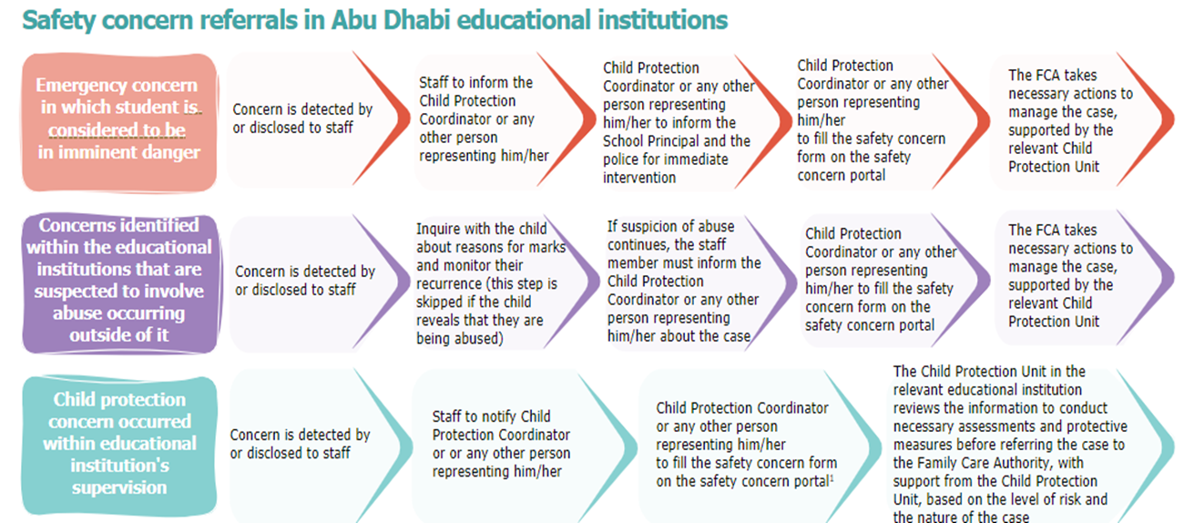
Relevant contact details are as follows:
- Abu Dhabi Police: 999​
- Ministry of Education Child Protection Unit: 80085; cpu@moe.gov.ae (for guidance)
- Family Care Authority: 800444; ICM@adfca.gov.ae ​
- Safety Concern Portal: daasafetyconcern.abudhabi
Note: To report or obtain more information on a child protection concern which occurred outside of or within educational institution’s supervision, the Child Protection Coordinator or any other person representing him/her can either call the MoE child protection unit’s hotline number (80085) for all schools and nurseries, or reach out to the relevant educational institution child protection unit by email (cpu@ese.gov.ae for public schools, cpu@moe.gov.ae for private schools, charter schools and nurseries.
Note: To report or inquire about child protection concerns within or outside the educational institution, the child protection coordinator or their delegate can either call the Ministry of Education's Child Protection Unit hotline at 80085 for all schools and nurseries, or email the Child Protection Unit of the relevant institution at cpu@moe.gov.ae.

Framework for the initial safety and risk assessment and referrals

As highlighted in the previous section, the relevant CPU reserves the right to conduct the initial safety and risk assessment, or to designate a qualified school personnel to conduct the initial safety and risk assessment. Alternatively, if the concern was referred to the FCA, a Case Manager at the FCA would conduct the initial safety and risk assessment.

Objectives of the initial safety and risk assessment

The initial safety and risk assessment allows the CPS at the relevant CPU and or the FCA to:
- Determine if there is reasonable cause to believe that a student was maltreated (past harm)
- Determine the current danger for the student (assessment of the child’s safety, current harm)
- Determine the future risk to the student (likelihood of harm occurring to the student in the future)

The initial safety and risk assessment should be completed by the CPS within two hours for emergency concerns, and within 24-48 hours for other concerns.
All student maltreatment concerns that result in the submission of the Safety Concern form, should be subject to an initial safety and risk assessment.
As a result of the initial safety and risk assessment, a determination should be typically made by the CPS as to whether the report is:
- Unsupported – Documented report suggesting why there was no reasonable cause to believe that the student was maltreated, or that the child’s safety or wellbeing was compromised
- Substantiated Concern – Reasonable cause to believe that the student was neglected and the actions or inactions by the perpetrator create the potential for abuse and/or neglect, but there is no immediate danger to the child’s safety or wellbeing; would also include cases where there is reasonable cause to believe that the student is facing harm or risk, with no substantiation
- Supported – Reasonable cause to believe the student was maltreated and the student is at risk; the actions or inactions by the parents/caregivers place the student in danger or pose substantial risk to the child’s safety or wellbeing, or the person was responsible for the student being a victim of sexual exploitation or human trafficking

The levels of risks

Three levels of risk were defined, in addition to the “no risk” level:

Low risk:
- The home is still safe for the student
- The current evidence does not indicate likelihood of serious harm
- The student is potentially at risk if services are not provided to prevent further maltreatment
Recommended intervention timeline: One week

Medium risk:
- The student is likely to suffer some degree of harm without an effective protective intervention plan
- There is limited evidence that the student is at risk of immediate serious injury or death
- The student is currently in the hospital
- The student has been the subject of notifications of concerns in the past two weeks (within or outside the educational setting)
- The student has previously been removed from the care of their family
- The student has siblings that have already been removed from the care of their family
- The student is currently living in a family environment with a known history of drug and alcohol abuse, mental illness, or domestic violence
Recommended intervention timeline: Within 72 hours

High risk:
- There are identifiable indicators of the potential risk of serious harm. The event could happen at any time and the impact would be serious
- The student needs urgent medical attention, is likely to be seriously harmed or injured (incl. self-harm), or subjected to immediate and ongoing sexual abuse, or be permanently disabled, trafficked, or killed if left in their present circumstances without protective intervention
- The student’s physical and health safety are endangered, requiring immediate intervention
Recommended intervention timeline: Immediate

The assessment framework

The framework for the initial safety and risk assessment includes seven dimensions:
- Student’s vulnerability
- Type, severity, and frequency of harm
- History of maltreatment
- Risk of further harm
- Extent of emotional harm
- Source of harm
- Parenting/caregiving skills
The description of the dimensions as well as the criteria to map them to the risk levels are as follows:

It is important to note that these tables are indicative, are by no means comprehensive and should not serve as a checklist for the CPS. The dimensions listed here are all interrelated and can influence and interact with each other. Therefore, it is extremely important that professional judgement be exercised while assessing the level of risk for the student.

It is also important to note that the initial safety and risk assessment is a dynamic process. The situation of the student and family continue to change, and any new information that becomes available should be considered in the re-assessment of the initial safety and risk of the student.

No Risk | Low Risk | Medium Risk | High Risk
- Students whose needs are met by standard universal services such as access to a general practitioner or school support, etc. | - Can take care of and protect themselves  - No special needs | - Requires the support of adult(s) for care and protection  - Mild to moderate special needs | - Completely dependent on adult(s) for care and protection  - Severe special needs
- Student’s vulnerability: Refers to the student’s ability to protect themselves. Factors such as the age of the student (e.g., young students), gender (e.g., girls), and special needs (e.g., disability, developmental issues, mental health issues, chronic illness) can increase the risk of a student of being maltreated. These risk factors also tend to be cumulative: for example, young girls with special needs are at a higher risk of maltreatment.

- Type, severity, and frequency of harm: Refers to the number of different types of maltreatment that were identified. For example, for a case of reported neglect, additional types of maltreatment such as emotional or physical abuse could also be identified, resulting in increased risk for the student. Severity relates to the extent of the harm caused (e.g., bodily injury) due to maltreatment. Frequency is a measure of the number of times the student has been maltreated over a given period. As the frequency increases, the risk of harm also increases.

No Risk | Low Risk | Medium Risk | High Risk
- No injury or signs of maltreatment | - Some injury or signs of maltreatment that does not require medical attention  - Occasionally left unsupervised or with unsuitable caregivers | - Significant injury or signs of maltreatment, possibly requiring medical attention  - Pattern of ongoing, infrequent maltreatment  - Occasionally left unsupervised or with unsuitable caregivers | - Severe injury or sexual abuse, most likely requiring urgent medical attention  - Pattern of ongoing, frequent maltreatment  - Occasionally left unsupervised or with unsuitable caregivers

- History of maltreatment: Measures the number of times any concern of maltreatment was reported earlier as well as additional unreported incidents that come to light as a result of the assessment. It is important to note here that lack of previous notifications does not necessarily mean a low level of risk for the student.

No Risk | Low Risk | Medium Risk | High Risk
- No past reports or credible statements to suggest a history of maltreatment | - Isolated incidents of past maltreatment (unreported)  - Unsubstantiated past reports of maltreatment | - Previous substantiated reports of maltreatment (identified as low risk)  - Credible statements of past maltreatment | - Previous substantiated reports of maltreatment (identified as a medium or high risk)  - Credible statements or documentation of past maltreatment

- Risk of further harm: Evaluates the likelihood that the student will be harmed again in the future.

No Risk | Low Risk | Medium Risk | High Risk
- There is unlikely risk of future harm for the student in the future | - There is some risk for the student to be harmed again in the future  - The alleged perpetrator may have caused serious harm in the past, but a repeat of such behavior is not probable | - Considerable risk of future harm  - The alleged perpetrator can cause serious harm if protective factors diminish or fail | - Ongoing harm being cause to the student that will continue in the future

- Extent of emotional harm: Refers to emotional/psychological harm caused due to lack of protection and wellbeing of the child. As a result, the abused student will often demonstrate behavioral concerns and developmental delays, as well as fear of their parent(s)/caregiver(s). While emotional harm may seem like an obvious consequence of all types of maltreatment, it is not always a consequence. Some students may develop resilience and coping mechanisms to deal with the maltreatment that they have been subjected to. On the other hand, emotional harm may not necessarily be caused due to maltreatment.

No Risk | Low Risk | Medium Risk | High Risk
- No emotional/behavioral concerns  - Comfortable living with parent(s)/caregiver(s) | - Minor emotional/behavioral concerns  - Student expresses minor concerns about living with parent(s)/caregiver(s) | - Emotional/behavioral problems, often leading to significant changes in student’s behavior, dress, mannerisms, social relationship, and academic regression and/or developmental delays.  - Student expresses concern or minor fear about living with parent(s)/caregiver(s) | - Extreme emotional/behavioral problems, with serious developmental delays or impaired social functioning  - Student is extremely fearful about living with parent(s)/caregiver(s)

- Source of harm: Measures the ease of access as well as ability of the alleged perpetrator to harm the student. Perpetrators who are related to the student (e.g., parents, siblings, grandparents, uncle), or have relationship with any member of the student’s family (e.g., family friend) have open access to the student and can therefore easily harm them.

No Risk | Low Risk | Medium Risk | High Risk
- The alleged perpetrator has no access to the student | - The alleged perpetrator has access but only when the student is under the supervision of a capable caregiver | - The alleged perpetrator has some unsupervised access of the child  - The alleged perpetrator is a member of the extended family, a family friend, a stranger to the family with some access to the student, etc. | - The alleged perpetrator has unlimited access of the student (for example someone who works at the educational institution)  - The alleged perpetrator lives in the same household as the student (parent/caregiver/sibling/domestic worker/driver/ etc.)

- Parenting/caregiving skills: Evaluates the skills of parents/caregivers that are necessary to take care of their children and ensure their protection. It measures the parents’ overall willingness and ability to protect them. Lack of knowledge and awareness, as well as mental health issues and history of substance/alcohol abuse are some common factors that impair the abilities of parents/caregivers to protect their children. In fact, these risk factors are highly correlated to child/student maltreatment and should therefore constitute high risk during assessment.

No Risk | Low Risk | Medium Risk | High Risk
- Appropriate parenting skills (in line with the child’s developmental needs)  - No mental health issues impairing parental capabilities  - No past/present alcohol and/or substance abuse | - Some gaps in parenting skills  - History of mental health issues with no current problem  - History of alcohol and/or substance abuse with no current problem | - Inconsistency in taking care of the child or moderate gaps in parenting skills  - Some mental health issues, potentially impairing parenting capabilities at times  - Moderate alcohol and/or substance abuse | - Unwillingness or inability to take care of the child  - Serious mental health issues impairing parenting capabilities  - Severe alcohol and/or substance abuse

For example, despite assigning medium risk level to both the type, severity, and frequency of harm, as well as the history of maltreatment, the overall initial and safety assessment may identify it as a high-risk case. In another example, a high risk of child’s vulnerability can be offset by the presence of strong parental support and the child’s resilience, resulting in an overall medium-risk level for the case.

Therefore, all the dimensions should be evaluated for all cases while undertaking the initial safety and risk assessment as the interplay of different factors will influence the determination of the final risk level. Professional judgment should be critically applied to conduct the initial safety and risk assessment, keeping the individual circumstances of the student at the core of the process.

Determining the overall risk level and the subsequent procedures required

Based on the risk assessment, the overall risk should be determined.

This should be mainly determined by the CPS and the designated Case Manager appointed by FCA, using their professional judgement, and making sure that the risk reflects the reality of the situation beyond the assessment analyzed on paper.

If all the dimensions score low, medium, or high then the overall risk level would typically mirror the dimensions or could even be one level higher.

All concerns being assessed as medium or high risk would typically need to undergo the comprehensive Child and Family Assessment, to assess the strengths and needs of the student and their family.

The comprehensive Child and Family Assessment would be the responsibility of the FCA.

Examples of procedures for concerns detected/disclosed in educational institutions by category of reporter

Disclosure from the concerned child

If the student is reporting maltreatment, it is likely that the student has experienced a situation that requires immediate attention.
- The reporter should ensure provision of immediate support, where required in emergency cases (where the student is in imminent danger, by contacting the nearest hospital where required, and/or the Abu Dhabi Police (on 999) depending on the situation)
- Support the student to recount their experience, carefully avoiding any “leading” questions and without communicating (verbally or through body language) any judgement – offer support through clarifying questions such as “How did you feel/react at that time?” and respond using “affirmative listening” language (e.g., I understand that you’re saying that you felt very uncomfortable when the incident occurred)
- If concerns persist, notify the Child Protection Coordinator or any other person representing him/her immediately (recommended)
- Child Protection Coordinator or any person representing him/her to fill in the Safety Concern Form on the safety concern portal. A copy will be automatically sent to the FCA, the relevant CPU in educational institution (MoE CPU or ADEK CPU), and MoI CPC.
- Continue monitoring the situation and provide additional information to the relevant CPU if needed
- Retain all notes in a secure file – retain notes for the period described under UAE legislations for information handling

Disclosure from parents

- The reporter should ask clarifying questions to better understand the reasons of concern (to the student and parents)
- If concerns persist, notify the Child Protection Coordinator or any other person representing him/her immediately (recommended)
- Child Protection Coordinator or any person representing him/her to fill in the Safety Concern Form on the safety concern portal. A copy will be automatically sent to the FCA, the relevant CPU in educational institution (MoE CPU or ADEK CPU), and MoI CPC
- Continue monitoring the situation and provide additional information to the relevant CPU if needed
- Retain all notes in a secure file – retain notes for the period described under UAE legislations for information handling

Disclosure from Students

- The reporter should establish rapport with the child, support the student, carefully avoiding any ‘leading’ questions and without communicating (verbally or through body language) any judgement and include any observed signs and symptoms of maltreatment
- If concerns persist, notify the Child Protection Coordinator or any other person representing him/her immediately (recommended)
- Child Protection Coordinator to allow the student to recount their experience in a safe, quiet location, reassure the student that you are there to help them
- Child Protection Coordinator or any person representing him/her to fill in the Safety Concern Form on the safety concern portal. A copy will be automatically sent to the FCA, the relevant CPU in educational institution (MoE CPU or ADEK CPU), and MoI CPC. Include statements disclosed by the student such as them stating they are fearful of returning home, so the FCA can take appropriate action to protect the student
- Continue monitoring the situation and provide additional information to the relevant CPU if needed
- Retain all notes in a secure file – retain notes for the period described under UAE legislations for information handling

Concerns identified by teachers

- In case of reasonable suspicion, ask the student clarifying questions
- If concerns persist, notify the Child Protection Coordinator or any other person representing him/her immediately (recommended)
- Child Protection Coordinator or any person representing him/her to fill in the Safety Concern Form on the safety concern portal. A copy will be automatically sent to the FCA, the relevant CPU in educational institution (MoE CPU or ADEK CPU), and MoI CPC.
- Continue monitoring the situation and provide additional information to the relevant CPU if needed
- Retain all notes in a secure file – retain notes for the period described under UAE legislations for information handling

Concerns identified by other school staff (e.g., nurse)

- In case of reasonable suspicion, ask the student clarifying questions
- If concerns persist, notify the Child Protection Coordinator or any other person representing him/her.
- Child Protection Coordinator or any person representing him/her to fill in the Safety Concern Form on the safety concern portal. A copy will be automatically sent to the FCA, the relevant CPU in educational institution (MoE CPU or ADEK CPU), and MoI CPC.
- Continue monitoring the situation and provide additional information to the relevant CPU if needed
- Retain all notes in a secure file – retain notes for the period described under UAE legislations for information handling

Concerns identified by auxiliary school staff (e.g., bus driver)

- The reporter should notify their immediate supervisor and the Child Protection Coordinator or any person representing him/her should be contacted
- In case of reasonable belief of maltreatment, the Child Protection Coordinator or any person representing him/her to fill in the Safety Concern Form on the safety concern portal. A copy will be automatically sent to the FCA, the relevant CPU in educational institution (MoE CPU or ADEK CPU), and MoI CPC
- Continue monitoring the situation and provide additional information to the relevant CPU if needed
- Retain all notes in a secure file – retain notes for the period described under UAE legislations for information handling

Examples of procedures for concerns that would be managed internally by the school

All concerns of student maltreatment should be reported to the relevant CPU via the safety concern portal.

Where the relevant CPU at MoE or ADEK, or the FCA, assesses, after the initial assessment, that the concern should be managed within the educational institution, then the process would be led by the Child Protection Coordinator or any other person representing him/her within the educational institution.
This includes sourcing and filling the below information:
- Part C: Child and Family Assessment to identify the protection needs of the student. This includes evaluating the student’s family situation, risk, and protective factors, as well as understanding if there have been any changes (e.g., behavioral, academic) observed in the student lately. The Child Protection Coordinator should record other information about the student and their family before deciding what to do about the concerns

Part D: Student Wellbeing Plan by engaging with all relevant stakeholders (e.g., student, parents, school counselor). The participation of the student should be highly encouraged, and they should be informed of the actions being taken at all stages

- Part E: Monitoring and Review of the Safety Wellbeing Plan to ensure proper monitoring of the implementation plan to ensure the student’s wellbeing

All relevant notes and documents should be retained in a secure file.

How should concerns be referred to the Child Protection Unit?

Who to contact for notification of concerns of student maltreatment

- All concerns of student maltreatment should be reported to the Child Protection Coordinator or any other person representing him/her in the school
- The Safety Concern Form should be filled by Child Protection Coordinator or any other person representing him/her on the safety concern portal. Once submitted, a copy of the Safety Concern Form will then be automatically shared with the relevant CPU in educational institution (MoE CPU or ADEK CPU), with the FCA and the MoI CPC.
- For concerns of maltreatment which occurred under the supervision of the educational institution, the Child Protection Unit within the relevant educational institution will review the information first before referring to the FCA for case management, who will take the necessary procedures to follow-up on the cases after receiving the report.

If the student requires medical support, what should be done

- For minor injuries, provide and keep record of medical support at the school
- For serious injuries or imminent danger to the child, immediately call an ambulance (on 998) or the Abu Dhabi Police (on 999)
- The mandated reporter should report the concern to the Child Protection Coordinator, who then notifies the CPU via a Safety Concern Form, or directly report the concern to the CPU

What forms to fill

Form and Section | Description
Parts B, C, D | Filled for concerns of maltreatment that do not meet the thresholds for reporting to the CPU (i.e., for concerns that will be handled by the schools)
The Safety Concern Form | Filled for all concerns of maltreatment detected in an educational institution

What happens after the concern is reported to the Family Care Authority

- The Safety Concern Form filled and validated by the CPS at the relevant CPU, along with the initial safety and risk assessment where applicable, would be shared with the FCA (the initial safety and risk assessment for concerns of maltreatment taking place outside the education setting, should be conducted by the FCA)
- A CPS (case manager) from the FCA will be appointed to manage the case
- The Case Manager will review the documentation shared by the CPU (within 24 hours) and will determine whether additional information is needed
- If the case has a criminal aspect, the Abu Dhabi Police would be notified for further investigations (while the FCA continues to manage the case)
- The Family Care Authority Case Manager would then start the process of a comprehensive Child and Family Assessment (within one week). The FCA case manager would develop a “Student and Family Response Plan”, if needed and ensure the implementation of the plan (by referring the student and family to education and social support services)

How should concerns about school personnel be managed

- Any allegation against any school personnel should be directly reported to the Child Protection Coordinator or any other person representing him/her
- Any allegation against the Child Protection Coordinator or any other person representing him/her should be reported to the school principal or vice principal (if the principal is not available)
- An internal investigation should be initiated on the allegation, and the alleged school personnel should be put on administrative leave while the case is under investigation. The investigation would be completed in collaboration with the CPU (MoE/ ADEK)
- If the allegation has proved to be true, immediate actions should be taken to report the case to the Abu Dhabi Police, and terminate the employment of the perpetrator
- Strict confidentiality should be maintained at all stages of the internal investigation

Engagement model with the student and family

Dealing with disclosures

Dos on handling disclosures from a student
- Identify a quiet, safe, and comfortable location to talk to the student
- Contain initial reactions by being patient, showing care and concern, listening with undivided attention, and taking the student’s story seriously
- Ensure the student feels safe and supported by responding in a calm way, and reassuring the student that this has happened to others and that they have done the right thing by confiding in you
- Ask open-ended questions to gather more information and clarify the situation (e.g., How did it happen? /What happened?)
- Refrain from asking further questions if the student starts feeling distressed
- Recognize the impact of culture on dealing with disclosures and maintain sensitivity
- Only record the facts as the student presents them. The notes should not reflect the opinion of the note taker
- Inform the student that the information will be confidential and only shared with people that will help to resolve the issue and that they will be informed of who they are
Don’ts on handling disclosures from a child
- Question the story’s validity in front of the student
- Interrupt the student while talking and sharing information
- Pressure the student to respond or to provide details and information against their will
- Promise that you will keep the story as a secret (reporting is mandatory, explaining this is to ensure their safety)
- Promise that things will get better (in some cases it may get worse before getting better)
- Refer to the alleged perpetrator using disparaging comments (it may be someone close to the student)
- Confront the alleged perpetrator and threaten to harm or punish him/her (it may cause more harm to the student)
- Interview other individuals involved in the case (this is done by relevant authorities as part of the investigation)
- Reach out to parents before reporting. Parents’ involvement can have adverse effects such as increase the risk of further maltreatment, force the student to recant the story, withdraw the student from school, increase the risk of suicide (especially in cases of incest)

How to engage with the student before, during and after notifying a concern

- Inform the student in an age-appropriate language that another person at the school (the Child Protection Coordinator) will be notified and may need to talk to them to provide them with help
- Also inform the student that additional authorities may be notified to help stop the maltreatment, and explain the role of these authorities, if appropriate
- Check whether the student is comfortable going home (in case they are not, treat it as an emergency)
- Keep the student informed of the actions being taken
- Monitor the student and the situation and provide necessary support to the student as well as the investigating authority
- If the student is moved to another school (for any reason), the Child Protection Coordinator should ensure that the new educational institution is aware of the case, if the case is currently open and the ongoing support needs of the student

How to engage with the family before, during and after notifying a concern

- In cases where the alleged perpetrator is not a family member, the Child Protection Coordinator should inform the family of the notification of the case, the next steps and the support required
- In cases where the student needs to be transferred to a hospital, school staff (and Child Protection Coordinator) should contact parents/guardians to inform them of actions being taken but are not obliged to obtain consent from family members if an emergency situation and the student’s wellbeing are at risk
- Engagement with the parents/guardians should be done in a student sensitive manner, catering for their language preferences and should be ideally conducted by the Child Protection Coordinator in the school

Confidentiality and information sharing

The relevant CPU would have a written data protection policy based on the principle of confidentiality to prevent any misuse of information. [Ref: ADEK Private Schools Policy & Guidance Manual]

Child Protection Coordinator, members of the Child Protection Team, CPS and other educational institution staff should be aware of the data protection protocols and the security implications of sensitive data.

All educational institution staff are required to protect information related to students involved in the suspicion of student maltreatment and not share it with anyone not directly involved in the care of the child. When information is shared, it should be on a need-to-know basis and limited only to the information necessary to enable better protection of the child.

The relevant CPU’s Head should update and ensure that data protection protocols are being followed through regular monitoring and mentoring of all staff including CPS, Child Protection Coordinators, and other staff.

  - Record keeping
- Information gathered on students should be allocated a code based on a standard coding format that guarantees anonymity of the student and is used to refer to the child’s case either verbally, on paper or electronically
- Any hard copies of the Safety Concern Form should be kept in a secure place, accessible only to the person responsible for the information
- Rooms containing paper or electronic information should be kept securely locked when the person responsible for the information leaves the room
- Electronic information on students should be password protected, the password changed on a regular basis and be transferred by encrypted or password protected files
- Computers should be fitted with up-to-date anti-virus software to avoid corruption and loss of information

  - Information sharing
- Information sharing with FCA or any other agency (e.g., Abu Dhabi Police, hospitals, etc.) for the purpose of referral should be strictly on a need-to-know basis, and only authorized personnel with clearance should be able to access information
- Information disclosed by students could be shared without consent in exceptional circumstances if it is considered – after careful evaluation – in their best interest to do so, but the reasons for doing so must be clearly explained to them
- The Child Protection Coordinator, members of the Child Protection Team, and other educational institution staff, as well as the CPS in the relevant CPU sharing information with or any other agency should be open and transparent

Training requirements

All educational institution staff (educators, other staff, and volunteers) should be trained on:
- Child protection practices
- How to identify signs of maltreatment
- How to actively listen to the student and what clarifying questions to ask the student and how to ask questions
- How and when to engage families
- How to engage with the student following identifying a maltreatment concern
- How to engage with the student when concerns have been validated
- How to report concerns to the Child Protection Coordinator/Child Protection Team
- Thresholds to report the concern to the CPU vs. resolving the concern within the educational institution
- How to address concerns of student maltreatment for students of determination
- What information can be shared and what information cannot be shared
All invited visitors shall also be required to attest to having read and understood the student protection policy.

Forms needed

Child Protection Safety Concern Form
Initial Safety and Risk Assessment Form

APPENDIX

      - Safety Concern Form

Child Details
Case Reference Number
Full Name | First | second | Third |  | Surname |  |  | Nickname
Nationality | Drop down menu with common nationalities in UAE + Other specify…………………. |  |  |  |  |  |  | Sex | Drop down menu  ❒ Male  ❒ Female
Religion | Drop down menu  ❒ Muslim  ❒ Christian  ❒ Hindu  ❒ Buddhist  ❒ Sikh  ❒ Jew  ❒ Other, please specify …………….. |  |  |  |  |  |  | Age | Drop down menu from 0 to 18  ❒ Is the age estimated?
Religion |  |  |  |  |  |  |  | Date of Birth | Drop down menu  Day\Month\year
Spoken languages | Drop down menu (you can choose more than one)  ❒ Arabic  ❒ English  ❒ French  ❒ Hindi  ❒ Urdu  ❒ Bengali  ❒ Tamil  ❒ Tagalog  ❒ Persian  ❒ Chinese  ❒ Malayalam  ❒ Other, please specify …………….. |  |  |  |  |  |  | Emirates ID number
Spoken languages |  |  |  |  |  |  |  | UID number
Spoken languages |  |  |  |  |  |  |  | If the child has communicative challenges, what is the best means of communication? | Drop down Menu  ❒ Through parents  ❒ Through siblings  ❒ Through family member  ❒ Through teacher  ❒ Through aid  ❒ Through Specialized Center  ❒ Other, please specify…………………………………….
Address (please mention nearest landmarks to address)
Incident details
Date of Incident | Drop down menu  Day\Month\year |  |  |  |  | Time of incident |  |  | Drop down menu  ❒ Morning  ❒ Noon  ❒ Evening  ❒ Night
Place of the Incident? |  |  |  |  |  | Where was the child at the time of the incident? |  |  | Drop down menu  ❒ At home  ❒ At Nursery (drop down menu with  name of all nurseries)  ❒ At School (drop down menu with  name of all schools)  ❒ At Extended Family  ❒ At Neighbors home  ❒ At family friend’s home  ❒ Other, please specify ………….
If in Educational institution what is academic level: | drop down menu  ❒ Nursery  ❒ Grade 1  ❒ Grade 2  ❒ Grade 3  Grades drop down to 12 |  |  |  |  | Suspected type of abuse |  |  | drop down menu, can select more than one option  ❒ Physical Abuse  ❒ Sexual Abuse  ❒ Emotional/Psychological Abuse  ❒ Neglect  ❒ Exploitation  ❒ Bullying/Cyberbullying
If physical or sexual abuse, have the police been contacted? | drop down menu  ❒ Yes  ❒ No |  |  |  |  | If yes, have they initiated any contact yet? |  |  | This question should be skipped if they mark “No”  (drop down menu)  ❒ Yes  ❒ No
Primary Caregiver Details
Name | First | Second | Third | Surname |  | Sex: |  |  | Drop down menu  ❒ Female  ❒ Male
Nationality | Drop down menu with common nationalities in UAE + Other specify…………………. |  |  |  |  | Age |  |  | Drop down menu from 18+  ❒ Is the age estimated?
Religion | Drop down menu  ❒ Muslim  ❒ Christian  ❒ Hindu  ❒ Buddhist  ❒ Sikh  ❒ Jew  ❒ Other, please specify …………….. |  |  |  |  | Date of Birth |  |  | Drop down menu  Day\Month\year
Religion |  |  |  |  |  | Emirates ID number
Religion |  |  |  |  |  | UID number
Relationship to child | Drop down menu  ❒ Mother  ❒ Father  ❒ Grandmother  ❒ Grandfather  ❒ Aunt  ❒ Uncle  ❒ Brother  ❒ Sister  ❒ Other, please specify……………… |  |  |  |  | Does this person live with the child |  |  | Drop down menu  ❒ Yes ❒ No
Relationship to child |  |  |  |  |  | Is this person alive? |  |  | Drop down menu  ❒ Yes ❒ No
Relationship to child |  |  |  |  |  | Is this person the primary caregiver |  |  | Drop down menu  ❒ Yes ❒ No
Relationship to child |  |  |  |  |  | Is this person the offender in this incident? |  |  | Drop down menu  ❒ Yes ❒ No
Spoken Languages | Drop down menu (you can choose more than one)  ❒ Arabic  ❒ English  ❒ French  ❒ Hindi  ❒ Urdu  ❒ Bengali  ❒ Tamil  ❒ Tagalog  ❒ Persian  ❒ Chinese  ❒ Malayalam  ❒ Other, please specify …………….. |  |  |  |  | Does this person have special needs? |  |  | Drop down menu  ❒ Yes ❒ No
Spoken Languages |  |  |  |  |  | If yes, please specify |  |  | ❒ Physical  ❒ Developmental  ❒ Emotional\Behavioral  ❒ Sensory Impairment
Address if different than above child address (please mention nearest landmarks to address) |  |  |  |  |  | Contact Details (phone number, email, etc.)
Alleged Perpetrator (if known)
If the alleged perpetrator is the primary care giver no need to repeat this info)
Name | First | Second | Third | Surname |  | Sex |  |  | Drop down menu  ❒ Female  ❒ Male
Nationality | Drop down menu with common nationalities in UAE + Other specify…………………. |  |  |  |  | Age |  |  | Drop down menu  ❒ Is the age estimated?
Relationship to child | Drop down menu  ❒ Mother  ❒ Father  ❒ Stepmother  ❒ Stepfather  ❒ Grandmother  ❒ Grandfather  ❒ Aunt  ❒ Uncle  ❒ Brother  ❒ Sister  ❒ Other, please specify……………………….. |  |  |  |  | Occupation
Relationship to child |  |  |  |  |  | Contact Details if known (Address, phone number, email, etc.)
Concern Details
Reporting Details Disclosure (please use exact words as relayed by child).
Suspected signs of maltreatment
Observations (if any, incl. date and time) | Drop down menu  ❒ Physical signs/appearance  ❒Behavioral and Emotional signs/actions  ❒ Verbal/communication responses  ❒Other, please specify………….. |  |  |  |  | Please narrate in more detail your observations:
Discussions (if any, incl. date, time, sources)
Does the child have any siblings that may be at risk? | Drop down menu  ❒ Yes  ❒ No |  |  |  |  |  | List any other siblings of the child that may be at risk |  | Drop down menu  - Age:  Sex: ❒ Male ❒ Female  - Age:  Sex: ❒ Male ❒ Female  - Age:  Sex: ❒ Male ❒ Female
Actions taken by mandated Reporter (if any) | Drop down menu\ More than one option can be chosen  ❒ Police have been contacted  ❒ Child has been informed that the concern is being reported  ❒ Non-offending parent has been informed that the concern is being reported  ❒ Offending parent has been informed that the concern is being reported  ❒ Other members of my child protection team have been consulted and aware  the concern is being reported  ❒ Other, please specify………………………………………..
Complainant Details
Name | First | Second | Third |  | Surname | Occupation
Spoken Languages | Drop down menu (you can choose more than one)  ❒ Arabic  ❒ English  ❒ French  ❒ Hindi  ❒ Urdu  ❒ Bengali  ❒ Tamil  ❒ Tagalog  ❒ Persian  ❒ Chinese  ❒ Malayalam  ❒ Other, please specify …………….. |  |  |  |  | Relationship to child |  |  | Drop down menu  ❒ caregiver  ❒ A family member that is not the primary care giver  ❒ friend  ❒ colleague  ❒ neighbor  ❒ No relationship  ❒ unknown  ❒ Other, please specify.......
Work Address |  |  |  |  |  | Contact Details (phone number, email, etc.)
Mandated Reporter Details
Name | First | Second | Third |  | Surname | Emirates ID number
Occupation |  |  |  |  |  | Work Address
Spoken Languages | Drop down menu (you can choose more than one)  ❒ Arabic  ❒ English  ❒ French  ❒ Hindi  ❒ Urdu  ❒ Bengali  ❒ Tamil  ❒ Tagalog  ❒ Persian  ❒ Chinese  ❒ Malayalam  ❒ Other, please specify …………….. |  |  |  |  | Relationship to child |  |  | Drop down menu  ❒ Teacher  ❒ Educational institution staff,  ❒ Doctor  ❒ Psychiatrist  ❒ Psychologist  ❒Others, please specify.......
Contact Details (phone number, email, etc.) |  |  |  |  |  | Who submitted the concern? |  |  | Drop down menu  ❒ CPS from health care  ❒ CPS from Educational  Institution  ❒ CPS from Family Care Authority  ❒ CPS from other entity  ❒ Mandated Reporter
Which Channel was used to submit the concern? | Drop down menu  ❒ FCA Portal  ❒ FCA Email  ❒ FCA call center  ❒ MOI\CPC – Hemayti app.  ❒ MOI\CPC – Portal  ❒ MOI\CPC - Email  ❒ MOI\CPC - Hotline  ❒ MOE Hotline  ❒ Police emergency phone line  999 |  |  |  |  | Permission to use of your information outside the case management system. |  |  | Drop down menu  ❒ Yes  ❒ No
Signature |  |  |  |  |  | Date |  |  | Drop down menu  Day\Month\year

Part B: Referral Decision

Part B: Referral Decision (to be conducted by the Child Protection Coordinator/other person representing him/her based on the information received in Part A and any additional information received from discussion with the reporter)
Action Taken
- Response to be provided in-school
- Case referred to MoE AND ADEK CPU
- Police notified (in cases where the child is at immediate risk of harm)

The following sections should be completed only for cases that will be managed by the school.
Part C: Child and Family Assessment

Part C: Child and Family Assessment (to be filled by the Child Protection Coordinator in coordination with relevant stakeholder, such as, the the reporter, the child’s class teacher, etc.)
Information about the child’s family
No. | Name of other adults in the household |  | Age | Gender | Relationship to the child
No. | Name of other children in the household |  | Age | Gender | Enrolled in the same school?
Parental risk factors (e.g., mental illness, domestic violence)
Any other risk factors?
Parental protective factors and/or family strengths
Any support service currently in place for the child and/or the family?
Any previous incident of maltreatment of another child in the household?
Any additional observations
Other information about the child’s safety and wellbeing
What is the present situation of the child?
Has the child’s situation changed lately? (e.g., changes in behaviors, academic performance)
Has the child expressed any views or opinions? What were they?

Part D: Student Wellbeing Plan

Part D: Student Wellbeing Plan (to be developed by the Child Protection Coordinator/any other person representing him/her in coordination with relevant stakeholders, such as the reporter, the child’s teacher, etc. The child and family, where possible, should be encouraged to participate in the development of the plan)
Issues that require in-school response
Educational
Emotional
Behavioral
Relationship
Other
Response plan (to address the issues identified above)
No. | Response action |  |  | Responsible person (name, designation, contact details)
What strengths does the child have that will assist in achieving the plan? (e.g., academic, social, creative)
What challenges does the child face that may get in the way of achieving the plan?
Do all relevant in-school staff know about the plan, and their role in implementing the plan?
How will the effectiveness of the plan be measured?
Did the child participate in developing the plan? (If no, why?)
Are the parents aware of the plan and in agreement with it? (If no, why?)

Part E: Monitoring and Review of the Student Wellbeing Plan

Part E: Monitoring and Review of the Student Wellbeing Plan
Issues resolved since last meeting
Issues requiring further actions
Recommendations/ additional remarks
Additional review required? (Please give reasons)
Next review date (if required)

      - Initial Safety and Risk Assessment Form

Case Reference Number
Referring Agency |  |  | FCA Location
Referral Date
Child Details
Full Name |  |  |  | Date of Birth
Nationality |  |  |  | Gender
Preferred Language |  |  |  | Emirates ID Number
Address
Contact Details (phone number, email, etc.)
Special Needs? (If yes, please provide details)

Father’s details
Full Name |  | Date of Birth
Nationality |  | Emirates ID Number
Preferred Languages
Address
Contact Details (phone number, email, etc.)
Special Needs? (If yes, please provide details)
Non-offending Parent?
Primary Caregiver?

Mother’s Details
Full Name |  | Date of Birth
Nationality |  | Emirates ID Number
Preferred Languages
Address
Contact Details (phone number, email, etc.)
Special Needs? (If yes, please provide details)
Non-offending Parent?
Primary Caregiver?
Primary Caregiver’s Details (if different from mother and/or father)
Full Name |  | Date of Birth
Nationality |  | Gender
Emirates ID Number |  | Preferred Languages
Address
Contact Details (phone number, email, etc.)
Special Needs? (If yes, please provide details)

Safety Interventions Taken Already

Interventions taken already to remove threat to the child (e.g., sending the child to the hospital).

Initial Safety and Risk Assessment (this form is for use by the FCA Case Manager, here included for informational purposes)
Dimension |  | Risk level |  |  |  |  |  |  | Please explain your assessment of the risk level
 |  | No Risk |  | Low |  | Medium | High |  | Please explain your assessment of the risk level
Child’s vulnerabilities (e.g., age, gender, special needs)
Type, severity, and frequency of harm
History of maltreatment
Risk of further harm
Extent of emotional harm
Source of harm
Parenting/ caregiving skills
Summary of the Risk Factors

Circumstances, conditions, or events that increase the probability of a child experiencing maltreatment
Summary of the Protective Factors

Protective factor are conditions or attributes in the child and their family as well as the community and the larger society that the child belongs to that mitigate or eliminate risks of child maltreatment, such as, high capacity of parents to meet the needs of the child, healthy relationship between the child and the parent(s).
Overall Risk Level

Based on the above assessment, identify the overall risk level. The decision should be based on the professional judgement of the practitioners and based on the analysis of all risk and protective factors, safety interventions undertaken, as well as any other information known about the case.
 | ⇨ Low |  |  |  | ⇨ Medium |  |  | ⇨ High
 | Briefly explain your observations and reason for selecting the risk level:
Did the child  participate in the Initial Safety and Risk Assessment? (If no, state why)? |  |  | ⇨ Yes  ⇨ No; reason(s): ___________________________________________

Recommended Safety Interventions
- Emergency removal of the child from the home
- Child and Family Comprehensive Assessment required (mandatory for all medium and high-risk cases)
- Case closure, referral of the child and/or family to support services

- Case closure, no further action required (notify the child and the family that no action will be taken)

- Other, please specify: _______________________________________________________________________________

Safety Plan
Safety Intervention | Actions Required | Responsibility | Timeframe
Please provide additional information on the safety intervention and/or safety plan:

Additional notes from the Case Supervisor and/ or the Case Manager (if any):

Name of Case Manager |  |  |  | Signature | Date
Name of Case Supervisor |  |  |  | Signature | Date

List of Policies to be Referenced:

- Abu Dhabi Child Protection Policy
- MoE National Policy for the Prevention of Bullying in Educational Institution
- MoE Cyberbullying Policy
- MoE National Policy on Child Protection in Educational Institutions in the United Arab Emirates
- ADEK Private Schools Policy and Guidance Manual (under revision)
- ADEK Private School Reopening Policies (2021)
- ADEK Student Protection Policy 2022
- ADEK School Staffing Policy
- ADEK Policy on Staff CPD/Licensing
- ADEK Policy on School Reports & Other Documents
- Link to ADEK Child Protection Compliance Framework

List of Systems to be Referenced:

- ADEK ESIS System
- MoE Student Information System

⁾ Time recommendations can be obtained from WHO recommended guidelines or those shared by mandated agencies within the UAE.
78 As per the United Nations, youth includes 15-24 age groups.
⁾ According to the UAE Labor Law, juvenile work permits can be granted for individuals between the ages of 15 and 18, under several conditions.
As per the Interagency Working Group on Sexual Exploitation of Children, “Child sexual abuse material” or “child sexual exploitation material” are now preferred alternatives to the term “child pornography”.
A similar training course is being made available for nursery, KG, and school staff as well

