
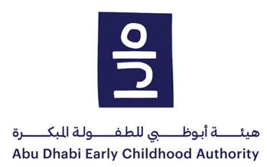

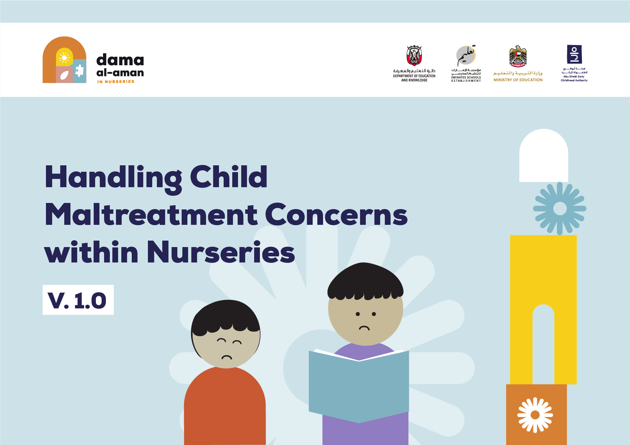

Table of Content

Introduction 5
1.1 Objectives of child maltreatment concern handling within nurseries 5
1.2 Who is this document for 6
1.3 Guiding principles 6
1.4 Benefits of establishing procedures for concern handling within nurseries 7
1.5 Glossary of terms used in the document 8
2 Operational definitions of child maltreatment 11
2.1 Physical abuse definition 11
2.2 Sexual abuse definition 12
2.3 Emotional and psychological abuse definition 13
2.4 Neglect definition 13
2.5 Exploitation 14
2.6 Bullying/cyberbullying definition 15
3 Signs, symptoms, and behaviors indicative of child maltreatment 17
3.1 Signs of physical abuse 17
3.2 Signs of sexual abuse 18
3.3 Signs of emotional/psychological abuse 19
3.4 Signs of neglect 20
3.5 Signs of exploitation 21
3.6 Signs of bullying/cyberbullying 23
4 Legal framework 24
4.1 What is mandated reporting of child maltreatment (according to the Wadeema Law – UAE Child Rights Law) 24
4.2 What are the implications of not reporting (according to the Wadeema Law) 26
4.3 Can a report be made anonymously (according to the Wadeema Law) 26
5 Roles and responsibilities in handling concerns of child maltreatment in nurseries 27
6 How nurseries should notify the authorities in case of child maltreatment suspicion 32
7 How should maltreatment concerns detected/disclosed in nurseries be managed 34
8 Framework for the initial safety and risk assessment and referrals 37
8.1 Objectives of the initial safety and risk assessment 37
8.2 The levels of risks 38
8.3 The assessment framework 39
8.4 Determining the overall risk level and the subsequent procedures required 44
9 Examples of procedures for concerns detected/disclosed in nurseries by category of reporter 44
9.1 Disclosure from the concerned child 44
9.2 Disclosure from parents 45
9.3 Concerns identified by teaching staff 45
9.4 Concerns identified by other nursery staff (e.g., nurse) 46
9.5 Concerns identified by auxiliary nursery staff (e.g., security guard) 46
10 Examples of procedures for concerns that would be managed internally by the nursery 47
11 How should concerns be referred to the Child Protection Unit? 47
11.1 Who to contact for notification of concerns of child maltreatment 47
11.2 If the child requires medical support, what should be done 48
11.3 What forms to fill 48
11.4 What happens after the concern is reported to the Family Care Authority 49
12 How should concerns about nursery personnel be managed 49
13 Engagement model with the child and family 50
13.1 Dealing with disclosures 50
13.2 How to engage with the family before, during and after notifying a concern 51
14 Confidentiality and information sharing 51
15 Training requirements 52
16 Forms needed 53

Introduction

Objectives of child maltreatment concern handling within nurseries

All children in Abu Dhabi should feel safe and protected. They have the right to be protected from harm wherever they are and protecting them is everyone’s responsibility. Infants and young children are particularly vulnerable due to their physical size, their dependence on adults, and their inability to escape harm and communicate when something is wrong. Many infants and young children spend a considerable portion of their time in nurseries, therefore efforts should be invested from all relevant stakeholders to ensure their protection. This includes the relevant government agencies (e.g., the Abu Dhabi Early Childhood Authority, the Abu Dhabi Department of Education and Knowledge, i.e., ADEK, the Family Care Authority, i.e., FCA), all staff and volunteers working in nurseries, parents, and the wider community. This also includes private organizations and NGOs, where relevant.

This document aims to provide guidelines to respond to concerns of child maltreatment within nurseries in the Emirate of Abu Dhabi.
It showcases the steps, roles and responsibilities of all nursery management, teaching staff, non-teaching staff and contractors (or auxiliary staff) in ensuring the protection of children, as stipulated in the relevant national laws and policies.

This document aligns with the procedures defined in the below national and Abu Dhabi level documentation (part of which are referenced later in the document):
- Abu Dhabi Child Protection Policy
- MoE National Policy for Bullying Prevention in Educational Institutions
- MoE National Policy on Child Protection in Educational Institutions in the United Arab Emirates
- Abu Dhabi Student Protection Policy for Educational Institutions
- ADEK Private Schools Policy and Guidance Manual
- ADEK Private Schools Reopening Policies (2021)

A complete list of documents references is included at the end of the document.

This document should also be considered jointly with the Abu Dhabi Child Protection Policy developed for nurseries.

Who is this document for

This document applies to and should be made available to all management, teaching staff and non-teaching staff (including Child Protection Coordinators, nurses, and ADEK CPU staff), admin staff, contractors/auxiliary staff (including cleaners, bus drivers, canteen workers, janitors, maintenance staff, security staff, and volunteers). An introduction to Abu Dhabi child protection practices in nurseries should be made available to parents/guardians and children.

Guiding principles

Best interests of the child: The best interests of the child must provide the basis for all decisions and actions taken in respect to the care and protection of all children (0-18 years). All nursery personnel must constantly evaluate the positive and negative consequences of actions and discuss these with the children where possible, and in an age-appropriate way, children and also with their parents/guardians when taking decisions. All actions should ensure that the child’s rights to safety and their on-going development should never be compromised.

Non-Discrimination: Nursery staff must ensure that all children receive appropriate care and support in their best interests, regardless of any individual characteristics, gender, age, socio-economic background, race, religion, ethnicity, or disability.

Child Participation: Children have the right to express feelings and share their experiences. Nursery staff are responsible for communicating and encouraging children to exercise their right to participate, by identifying and promoting age-appropriate ways to hear their voice throughout the maltreatment concern handling process.
child
Confidentiality: All information should ensure the child and family's privacy and confidentiality (both the victim’s and the perpetrator’s), documentation and storage of all information should be maintained within a secure system and information should primarily be shared only with child protection officials, who have been assigned to follow-up on the concern. When information is shared, it should be on a need-to-know basis and limited only to the information necessary to enable better protection of the child/perpetrator.

Mandatory and timely reporting: All nursery staff are required (per Federal Law No. 3 of 2016 on Child Rights) to adopt the principle of mandatory and timely reporting to the relevant authority in case of disclosure, suspected maltreatment and identification of a child maltreatment concern that was identified within the educational institution’s campus and its surroundings, its facilities, transport buses or during external activities organized by the nursery or the ministry. (The process of handling child maltreatment concerns is discussed in sections 5-8 of this document.)

Benefits of establishing procedures for concern handling within nurseries

The child protection system developed for Abu Dhabi provides regulations and guidance for preventing, responding to, and handling of child maltreatment cases.

The Child Protection Policy implemented within nurseries should be aligned to procedures described in this document.

In addition, all nurseries should implement child protection guidelines and practices, and staff training should be provided.

The procedures in this document result in multiple benefits for the various target groups, highlighted below:

Benefits for children:
- Learning about their rights, and about safety and protection in general
- Representation of their voices, and ensuring their participation
- Access to the support needed (incl. counselling and guidance services if needed)

Benefits for parents:
- Greater knowledge of child protection mechanisms within nurseries
- Greater trust in nurseries
- Signposting to relevant services

Benefits for nursery staff (incl. auxiliary staff and volunteers):
- Early identification of children at risk of harm or at risk of being maltreated in nurseries
- Responding quickly to child maltreatment concerns and referring children to relevant authorities (e.g., FCA, the Abu Dhabi Police, hospitals, etc.)

In addition, this document leads to benefits for ADEK:
- Supporting the roles and responsibilities of ADEK and for nurseries to provide protection and a safe learning/play environment for children, free from harm and violence
- Ensuring the alignment and consistency of handling child maltreatment concerns in all nurseries in Abu Dhabi
- Ensuring the alignment and coordination within the overall child protection system in the Emirate of Abu Dhabi

Glossary of terms used in the document

Below are the definitions of key terms used across this document:
- Allegation of child maltreatment: An allegation made by a child or adult to nursery staff that a child has been maltreated.
- Disclosure of child maltreatment: A disclosure made by a child to nursery staff that they have been maltreated
- Suspicion of child maltreatment: Nursery staff seeing or hearing something that makes them think that a child has been maltreated.
- Auxiliary staff: Contractors and volunteers working at the nursery (e.g., bus drivers, cleaners, canteen workers, janitors, security staff, etc.)
- Child: Any resident of the UAE under 18 years of age
- Child maltreatment: Any act or omission of act that would cause harm to the child and prevent his/her upbringing and development in a sound, safe and healthy manner including forms of physical, emotional, and sexual abuse and neglect, exploitation, bullying and cyberbullying
- Child protection: All measures, steps and actions that must be taken to prevent, protect and support children from risks that may cause harm or injury while they are under the supervision of the nursery, travelling to and from the nursery using institutional transport, and moving between, waiting for and taking part in all activities organized by the nursery inside or outside its premises child
- Child Protection Coordinator (CPC): Appointed staff member at the nursery who is professionally relevant, trained and equipped with skills to act upon child protection concerns that arise within their nursery and is the key contact for staff and authorities where a concern is identified within the nursery. The CPC should also be the point of contact for the nursery to respond to emergencies, report to the CPU and other authorities involved, liaise with parents, and provide ongoing support to the child
- Child Protection Unit (CPU): Organizational unit at MoE, ESE, and ADEK aiming at developing and implementing child protection measures for nurseries in the Emirate of Abu Dhabi in accordance with Federal Law No. 3 of 2016 and its bylaws. The Units are responsible for receiving and assessing child maltreatment concerns, in line with the procedures detailed in this document, along with the Child Protection Policy for Educational Institutions.
- Child Protection Specialist (CPS): The person authorized by MoE, ESE, and ADEK and the Abu Dhabi Judicial Department and the/Ministry of Community Development to preserve and protect the rights of the child, each within its specialization, in accordance with Federal Law No. 3 of 2016 on Child Rights (commonly known as Wadeema Law), its bylaws and Cabinet Resolution No. 52 of 2018 Governing the Executive Regulations of Federal Law No. 3 of 2016 on Child Rights.
- Child Protection System: Set of coordinated mechanisms between various organizations to ensure the promotion, prevention of and appropriate response to child protection concerns. The education sector has a key role to play in protecting children
- Child Protection Team: Team led by the Child Protection Coordinator, and should include a deputy coordinator, and other relevant staff member, forming the case management unit for all cases that are to be resolved in the nursery. In nurseries where such a team cannot be formed (e.g., due to resource limitation), the Child Protection Coordinator would be responsible for the internal case management, and a delegate should always be nominated in case the Child Protection Coordinator is not available/unable to perform their duties
- Consent: Written permission to provide/receive services and to release relevant information to other entities, signed by the child (where the child is 13 years of age or older) and/or the parent/authorized caregiver
- Corporal punishment: The act of inflicting physical pain for the purpose of punishment (e.g., by caning, flogging) to discipline a child
- Family Care Authority (FCA): The Abu Dhabi Authority responsible for child protection case management, established under Law 4 of 2021
- Handling child maltreatment concerns: Process of organizing and carrying out work to respond to children protection concerns in an appropriate, systematic, and timely manner. This can be completed through direct support from the nursery and/or referrals to other concerned entities (for more serious or complex cases of maltreatment)
- Identify/detect: Recognition of signs/risk of suspected child maltreatment through suspicion, experiencing or witnessing, and/or disclosures from the child, other children, parents/guardians, nursery staff or any other person in or outside of nurseries
- Initial safety and risk assessment: Analysis of information obtained from a disclosure or report to weigh the severity of a case, likelihood of harm and the impact of the report on a child’s development and functioning; resulting in the decision of whether there is a need for further investigation by the Police, or for a referral to the FCA
- Invited visitor: An individual visiting the educational institution on a temporary basis to interact with students (e.g., a speaker, career fair representative, etc.)
- Mandated reporter: A person who is required by law (under Article 42 of Federal Law No. 3 of 2016 on Child Rights, commonly known as Wadeema’s Law) to report child maltreatment concerns related to children to the Child Protection Specialist. This includes the educators in nurseries, or any adult on nursery premises or outside the nursery premises from which the child requests assistance in notifying the authorities (e.g., the Police, MoI-CPC, MoE, ESE and ADEK) about his/her suffering or any other child’s suffering.
- Notify: Informing the Child Protection Coordinator or relevant entities (e.g., child protection hotline at the Ministry of Interior, i.e., MoI-CPC), Police, ADEK CPU or the FCA) when child maltreatment is suspected
- Nursery supervision: Under the care and supervision of the nursery whether on the nursery premises or travelling on field/residential trips within the UAE or overseas
- Parent/guardian/caregiver: The person legally liable for a child or entrusted with their care, defined as the custodian of the child as per the Federal Decree Law No. 3 of 2016 Concerning Child Rights. (Wadeema’s Law).
- Reasonable belief of maltreatment: An objective basis for the belief that maltreatment has occurred; however, it does not require certainty (includes observing the maltreatment themselves, hearing from the child that maltreatment occurred, receiving information from another source, etc.)
- Report: Documenting a concern of child maltreatment (after receiving a Safety Concern Form) by the Child Protection Specialist at ADEK or FCA, based on unified parameters for the initial assessment, and officially communicating it to the relevant authorities
- Risk of harm: Harm which has not yet occurred but is likely to in the future, given risk factors identified in the present
- Safety Concern Form: Template form to be filled by a mandated reporter and/or the Child Protection Coordinator within nurseries, to report any disclosure and/or suspected case of maltreatment

Operational definitions of child maltreatment

The following definitions are the approved operational definitions for child maltreatment, used across all sectors involved in the protection of children 0-18 years within the Emirate of Abu Dhabi.

Further examples specific to the early years (click here)

Physical abuse definition

An intentional physical act or failure/unwillingness to act that results in, has a high likelihood of resulting in, or poses a threat of resulting in immediate and/or long-term physical injury or harm for the child’s health, survival, and development

Examples include:
- Hitting the child with hand, fist, or other object such as wooden spoon, shoes, belt, etc.
- Kicking or biting the child in soft areas of the body such as the head, face, ears, stomach and/or genitals
- Causing bruises, bleeding, or fractures of bones
- Pulling the arm or the hair of the child intentionally to cause harm
- Shaking or pushing the child violently, or throwing the child around causing injuries
- Tying, caging, or chaining the child
- Fabricating, intentionally exaggerating or inducing illness that may result in harmful medical evaluation or treatment of the child
- Stabbing, choking, burning, drowning, electrocuting, poisoning, unexplained injuries, untreated injuries or giving the child-controlled substances not prescribed for the child by a practitioner

Corporal punishment is considered physical abuse.

A physical act carried out by a person in power and authority against a child, that deliberately physically hurts and humiliates the child to cause pain or discomfort; however, light as a method of discipline.

Examples include:
- Smacking, slapping, spanking the child with hand or object such as a shoe, belt, “egal”, wooden spoon or paddle
- Pinching, biting, or pulling the child’s hair
- Kicking, throwing, pushing, or shaking the child
- Forcing the child to stand in an unpleasant position or under the sun, or in positions that cause them physical harm and pain
- Forcing the child to digest hot spices, washing their mouth out with soap
- Inflicting burns or cuts to the child

Sexual abuse definition

It is the coercion, attraction, or involvement of a child in sexual activity that they may or may not fully comprehend, or that violates the laws or social taboos of society. Activity could also include practices that do not involve any physical contact, such as involving children in watching or producing pornographic material, watching sexual practices, or encouraging children to behave in inappropriate sexual ways. Child sexual abuse is evidenced by the activity between an adult and a child, or between children, who by age or development is in a relationship of responsibility, trust, or power. The intent of the activity is to gratify or satisfy the needs of the other person.

Examples include:
- Sexting or sharing with the child sexual images or materials that include sexually explicit language
- Grooming the child through verbal, written or physical behavior for future sexual abuse
- Encouraging the child to behave in a sexually inappropriate manner; or to expose themselves indecently for the purpose of the perpetrator’s sexual gratification; or for purposes of shaming, humiliating, or exerting control over the child
- Fondling and kissing the child inappropriately, or using body weight to force an act for the purpose of sexual gratification of the perpetrator, or for purposes of shaming, humiliating, or exerting control over the child
- Intentional masturbation of the perpetrator or exposure of the perpetrator’s genitals in the presence of the child
- Rubbing and touching the child inside or outside of clothing
- Penetration or contact between the genitals of the child and the genitals of the perpetrator
- Rape or incest

Emotional and psychological abuse definition

An act, whether consistent or inconsistent, offensive to the child’s psyche by making a child feel unloved, worthless and of no value and integrity, often causing severe permanent damage interfering with the child’s positive mental and emotional development

Examples include:
- Insulting, aggressing, humiliating, shaming, or intimidating the child, or conveying to a child that he/she is worthless, unloved, or unwanted
- Frightening or threatening the child to cause physical harm to the point of anxiety
- Blaming the child and making him/her a scapegoat to the point of negatively impacting the child’s self-esteem and self-worth
- Imposing on a child inappropriate expectations that are beyond his/her developmental capability, thus causing serious emotional discomfort
- Discriminating negatively between the child and others with the purpose of degrading them
- Not providing an opportunity for the child to express views or deliberately silencing him/her, or gagging the child’s mouth
- Restricting the child’s movement, or confining/imprisoning the child in a small space
- Forcing the child to witness domestic violence

Neglect definition

Failure of a parent or caregiver to provide for/protect the basic needs and rights of a child to protect their life, physical safety, development, psychological, mental moral integrity and wellbeing, that may lead to a failure to thrive in the context of the resources reasonably available to the family and/or caregiver and causes or has a high probability of causing significant harm to the child’s health and/or physical, social, educational, mental, spiritual or moral integrity.

Examples include:
- Failing to protect the child from abandonment and maintaining regular contact with the child
- Failing to provide the minimum required emotional support and love to the child to ensure their sound development and wellbeing
- Failing to meet the child’s basic needs including ensuring an adequate level of food, housing, hygiene, clothing, and basic medical services (incl. any specialist medical care the child may need, e.g., for asthma or diabetes) and vaccinations
- child Permitting the child to live under conditions injurious to their wellbeing such as substance use by parents/caregivers, exposure of the child to family violence or other violent events
- Leaving the child at home without proper supervision, or leaving them in the car depending on their age, level of development, cognitive abilities and/or verbal abilities
- Leaving the child with an adult who is not a family member, and who is not related to the child in any way
- Allowing the child to use digital devices for an excessively long period of time daily
child children

Exploitation

Use of the child in work or other activities for the benefit of others. This includes, but is not limited to, child labor and exploitation of children in prostitution or involvement of the child in gangs, militia, or military. These activities are to the detriment of the child’s physical or mental health, education, moral or social development.

Sexual exploitation

Form of sexual abuse where there is an abuse of power by a youth, adult or group who may coerce, manipulate, or deceive a child into sexual activity by physical contact and/or use of technology for monetary, social, or political profits.

Examples include:
- Notifying the child that they are in debt in exchange of gifts or attention received
- Uploading or purchasing sexual abuse material of children online
- Introducing the child to a party-based lifestyle with sexual acts, drugs, alcohol, or deceiving and coercing, to sexually groom a child
- Sharing or threatening to share indecent images, films, or drawings, engaging the child in pornographic material, and blackmailing them
- Involving a child in prostitution, sexual slavery, and sex tourism, or coercing the child to participate in sexual acts with others, or using physical violence to defeat the child’s will (such as gang-rape)

Economic exploitation

Use of a child who is below the minimum age of labor in the workplace or related activities for the benefit of others through the production, distribution, and consumption of goods or of a particular service delivered by the child.

Examples include:
- Selling and trafficking a child
- Engaging children in armed conflict
- Engaging a child in begging, or selling and distributing narcotic drugs for use in other criminal acts
- Employing a child in domestic services, working in shops, working in farms

Bullying/cyberbullying definition

Bullying

Repeated physical, psychological, social, or verbal aggression exercised by children who feel they are in a position of power against other children who are perceived weaker or powerless, to achieve specific gains or draw attention, in a way that hurts the child physically and/or emotionally; bullying can be committed by groups or individuals, in online (cyberbullying) or offline settings.

Examples include:
- Giving the child menacing stares or hand signs, chasing the child, physically threatening the child, or threating to harm their family, or exercising physical violence against the child (beating and kicking)
- Damaging belongings, taking the child’s food, or intentionally destroying the child’s medicine
- Ignoring the child, excluding the child intentionally from a group or forming coalitions against him/her
- Name-calling, mocking, teasing, constantly criticizing or undermining the child

Cyberbullying

Bullying that takes place online using electronic devices such as computers, tablets, and smart phones typically by sharing/sending true or false comments or pictures/videos. Online bullying can follow the bullied child wherever they go and usually spreads beyond the initial perpetrator as it has a wider reach than bullying in the real world, via social networks and mobile phones.

Examples include:
- Impersonating the child on the internet and posting content on their behalf, to embarrass or cause trouble to them
- Sending the child threatening or abusive text messages or messages on social networks (incl. grooming via online gaming)
- Creating and posting inappropriate and embarrassing photos and videos, and shaming the child online
- Setting up hate sites or groups about a child, and voting for or against a child in abusive polls

Signs, symptoms, and behaviors indicative of child maltreatment
Selected examples of physical, emotional, and social behaviors of the child that are indicative of maltreatment are highlighted below.

Signs of physical abuse

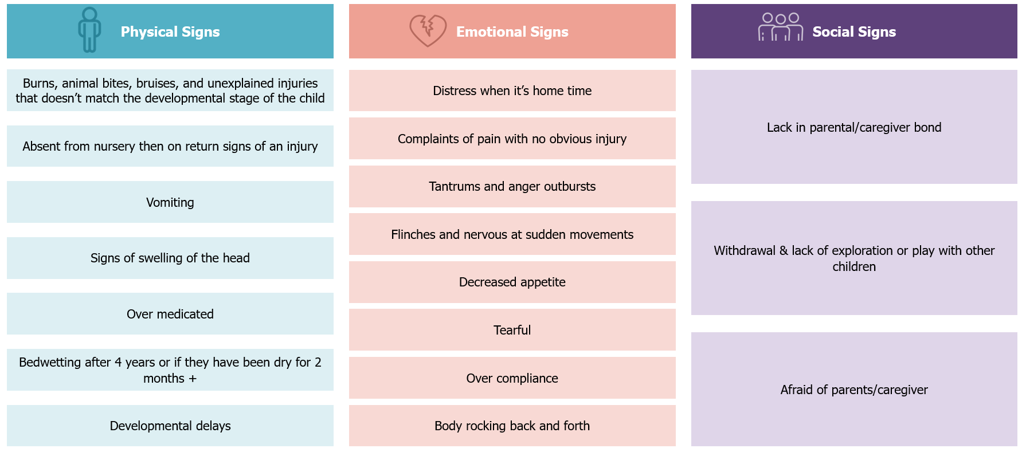

Signs of sexual abuse

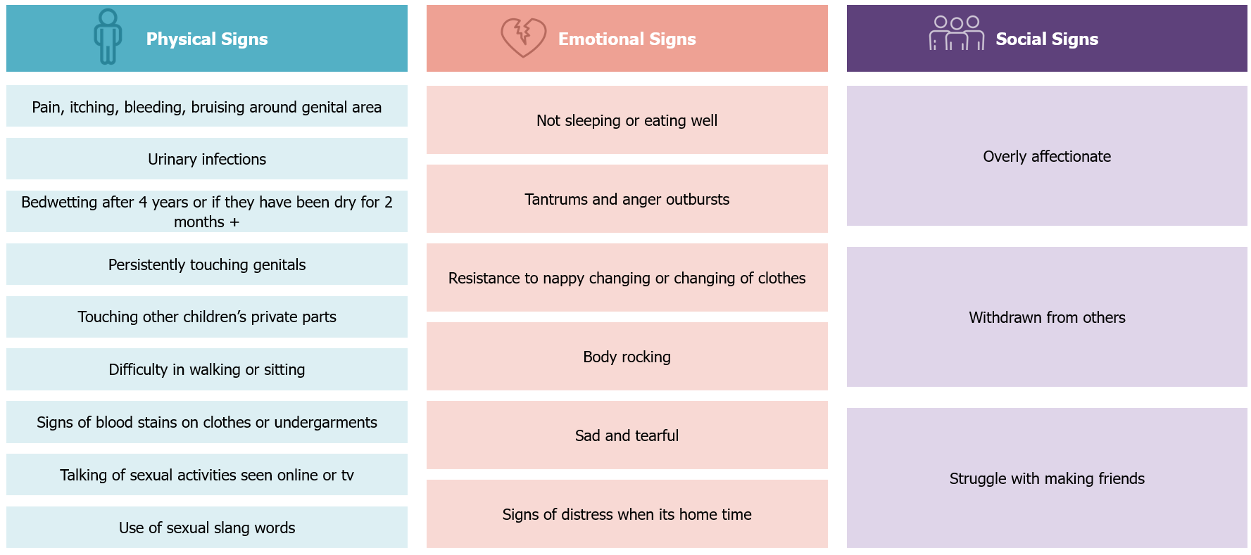

Signs of emotional/psychological abuse

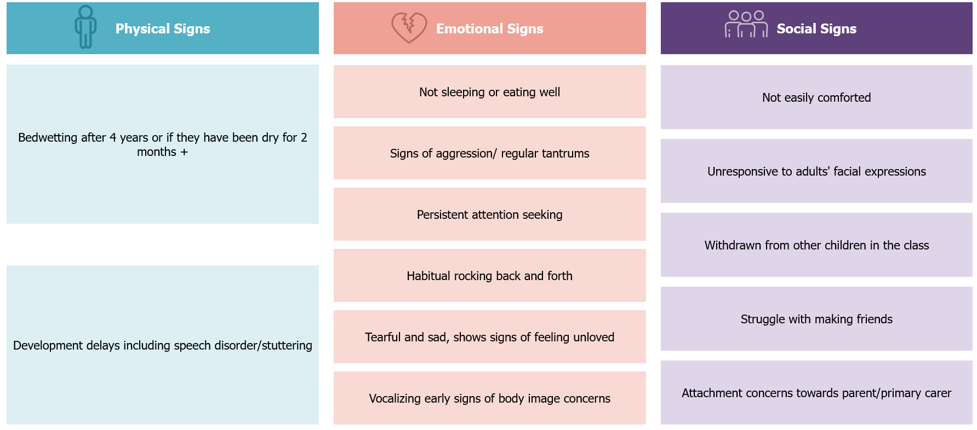

Signs of neglect

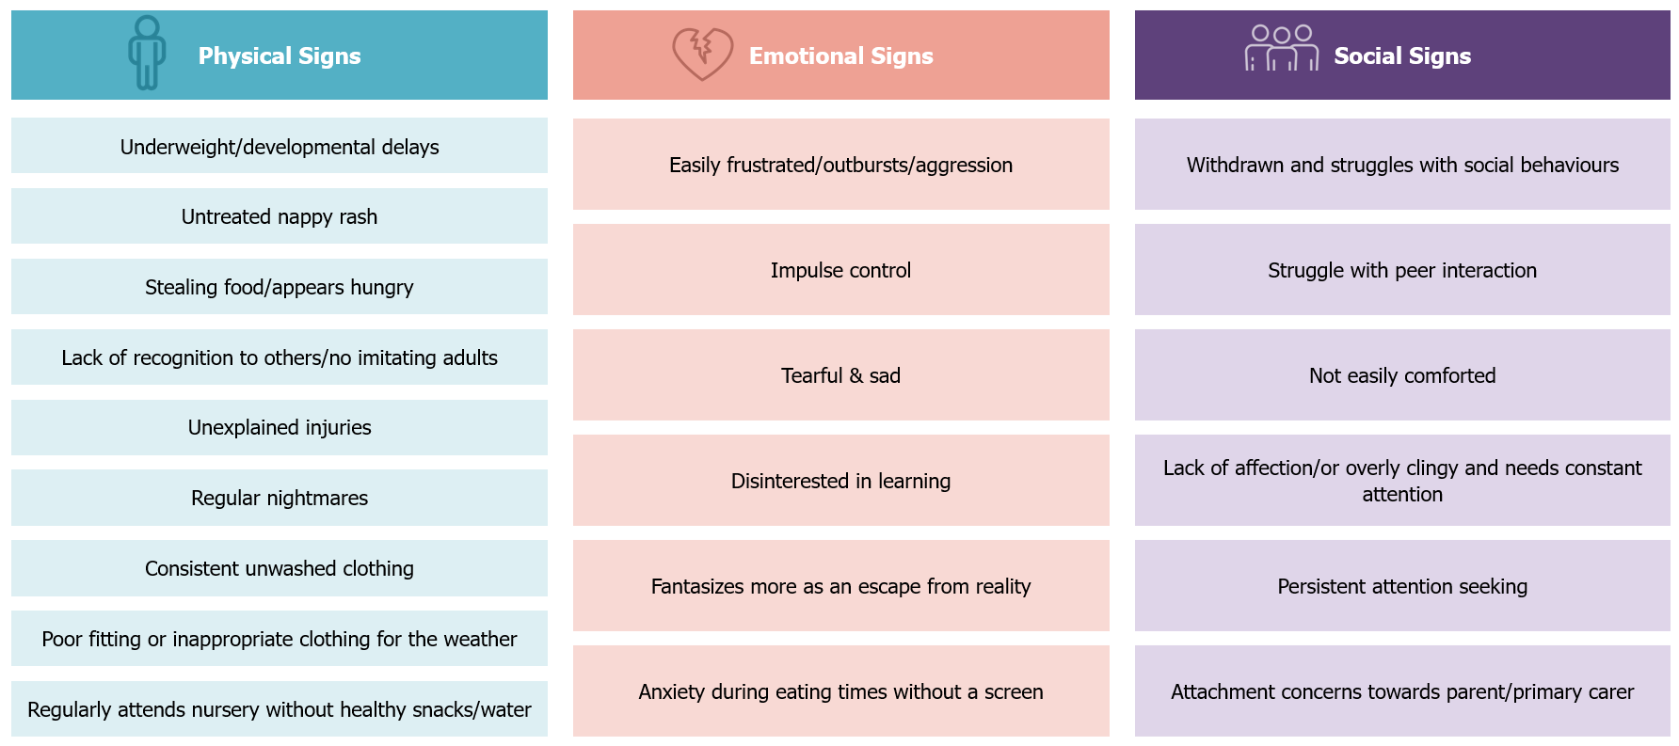

Signs of exploitation

Sexual exploitation

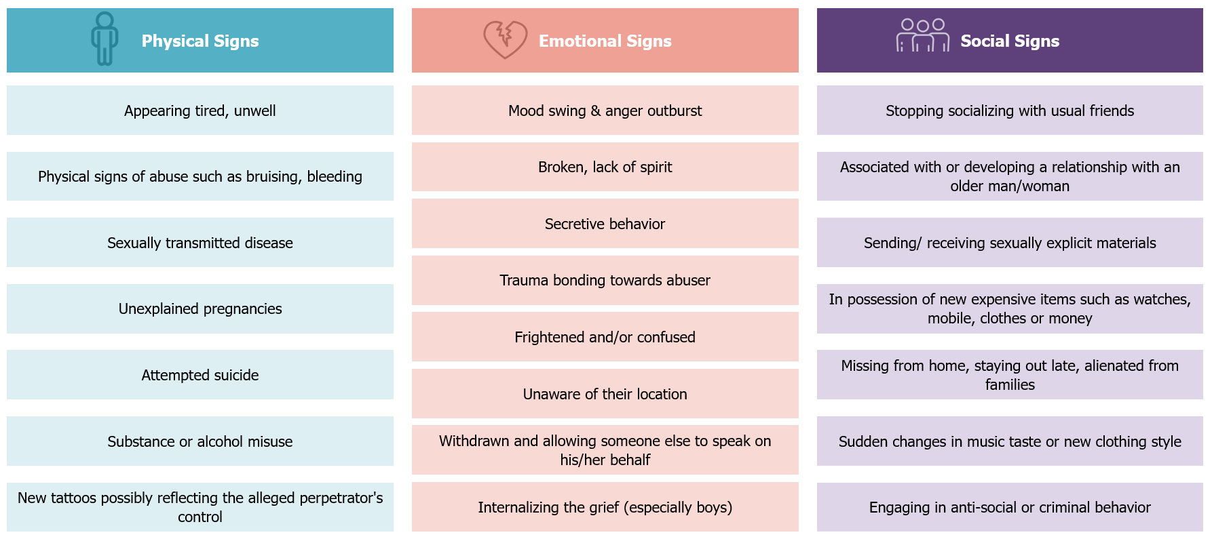

Economic exploitation

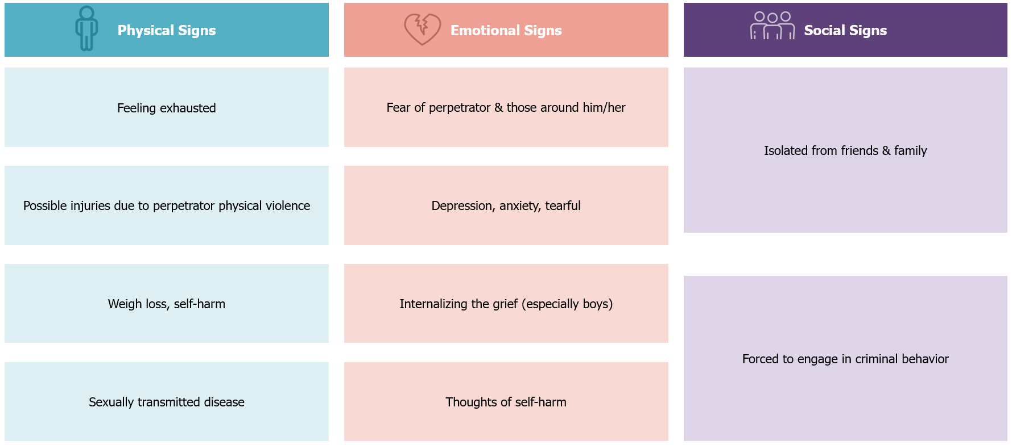

Signs of bullying/cyberbullying

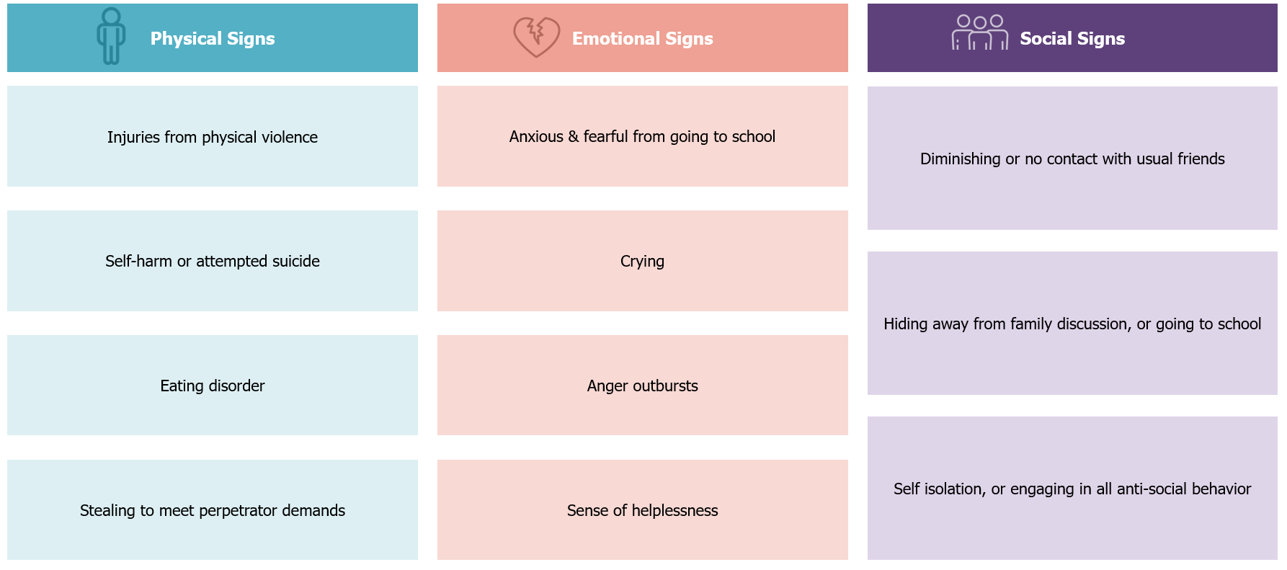

Legal framework

What is mandated reporting of child maltreatment (according to the Wadeema Law – UAE Child Rights Law)

Article 42 of Federal Law No. 3 of 2016 Concerning Child Rights (i.e., referred to henceforth as the “Wadeema Law”) states that Every person shall notify the child protection specialist or child protection units in case of anything that threatens the child's physical, psychological, moral, mental integrity, or health.
The notification shall be mandatory for the educators, physicians, social specialists, or others entrusted with the protection, care, or education of the child.

The Law makes it also mandatory to report maltreatment in case the child asks for someone’s assistance.
Article 43 states that Every person who reaches the age of majority shall assist any child who asks him/her to notify the competent authorities or concerned entities about their suffering, the suffering of any of their siblings or any other child in one of the cases set forth in Article 33 hereof.

As a result, the following non-exhaustive categories of professions are considered mandated reporters:
- Teaching staff, non-teaching staff, admin staff, contractors/auxiliary staff and other employees in public and private nurseries, charter nurseries and nurseries
- Administrators or employees of licensed community care or child daycare facilities
- Administrators or employees of day camps, child and youth centers, or child and youth recreation programs
- Social workers and social service workers within social institutions
- Employees at social assistance, social protection and family and marital counseling programs (incl. family and marriage therapists)
- Domestic workers with a caregiving responsibility
- Foster parents, alternative family members and personnel of residential care facilities for children
- Police officers, and other employees in Police departments
- Probation officers and parole officers
- Prosecutors and judges
- Forensic doctors
- Physicians, surgeons, psychiatrists, psychologists, dentists, residents, interns, licensed nurses, dental hygienists or social workers and other employees within health facilities
- Alcohol and drug counselors
- Child visitation monitors (sheltering facilities, courts)
- Religious service providers and employees of religious centers and/or services
- Athletic coaches and administrators, or other employees of out of nursery programs and sports clubs
- Commercial film and photographic print or image processors, computer technicians
- Security employees
- Volunteers/interns tasked with assisting the above-mentioned professions
- Any other persons who are directly/indirectly affiliated in providing children with direct services, programs, and/or activities

In addition, Article 29 states that the telecommunications companies and internet service providers shall notify the competent authorities, or the concerned entities of any child pornography materials being circulated through the social media sites and on the Internet and shall provide necessary information and data on the persons, entities or sites that circulate such material or intend to mislead the children.

As such, the following categories of professions are also considered mandatory reporters:
- Telecommunications
- Internet services
- Photography/filmography

A report is required by mandated reporters when the following circumstances apply:
- A mandated reporter, in his/her professional capacity or within the scope of his/her employment, has knowledge of or observes a child whom the reporter knows or reasonably suspects of being maltreated
- A person is called upon to provide aid to any child who is suffering from an injury that reasonably appears to have been caused by maltreatment
- Individuals who have knowledge of or observe any film, photograph, videotape, negative or slide depicting a child under age 18 engaged in an act of sexual conduct
- Technicians/telecommunications employees have knowledge of or observe, within the scope of their professional capacity or employment, any representation of information, data or an image, including, but not limited to, any computer hardware, software, file, floppy disk, data storage medium, CD-ROM, computer-generated equipment or computer-generated image that is retrievable in perceivable form and that is intentionally saved, transmitted or organized on an electronic medium, depicting a child under age 18 engaged in an act of violation of children’s rights

What are the implications of not reporting (according to the Wadeema Law)

Article 60 of the same Law states that Whoever violates the provisions of Clause 2 of Article (42) of this Law shall be punished by imprisonment or a fine not less than AED 5,000 (five thousand).

Not reporting maltreatment when asked by a child is also punishable by Law. Article 61 states Shall be punished by a fine not less than AED (5,000) five thousand and not exceeding AED (50,000) fifty thousand, whoever violates the provisions of Article (43) hereof.

Can a report be made anonymously (according to the Wadeema Law)

Reporting a child maltreatment concern can be made anonymously. Article 44 of the Wadeema Law stipulates that the identity of the reporter shall only be disclosed with his consent, and it shall be forbidden to disclose the identity of all the parties of the incident and the witnesses in the cases of child assault or abuse, upon using the information in the analyses or media reports or upon publishing all that may reveal his identity. While Article 45 ensures that the concerned and competent entities shall provide protection to the witnesses at all stages of the criminal proceedings.

Roles and responsibilities in handling concerns of child maltreatment in nurseries

Child Protection Unit (CPU):

All Abu Dhabi nurseries have access to the ADEK Child Protection Unit (CPU). The CPU is the protective mechanism for all nurseries in the Emirate of Abu Dhabi and aims at developing and implementing child protection measures.

Relevant ADEK Child Protection Unit’s key roles and responsibilities include:
- Develop, monitor, and enforce child protection policies and child protection measures
- Support nurseries in developing their child protection policies where needed.
- Introduce a broad range of child protection standards to the inspection framework, monitoring and working with nurseries falling below expectations by providing the necessary support
- Collaborate with relevant entities on the design and implementation of safeguarding programs.
- Receive and filter reports of concern of child maltreatment (neglect, physical and emotional abuse) and notifications (sexual abuse and exploitation) happening within nurseries and take necessary actions
- Refer concerns involving a maltreatment suspicion of a staff of a nursery towards a child to the relevant entities
- Activate procedures related to bullying in alignment with relevant entities
- Cooperate with and facilitate sharing of education-related information for child maltreatment comprehensive assessments and/or investigations being conducted by the relevant entities
- Follow up, if needed, with the relevant entities on the referrals made to them for cases in nurseries
- Document all notifications and/or reports received in confidential records that can be accessed only by Child Protection Specialists or any other concerned agency(ies), where needed, based on established information sharing protocols

Child Protection Specialists (CPS):

The CPSs that support Abu Dhabi nurseries are trained, and licensed professionals employed by ADEK CPU. The ADEK CPSs should receive the training approved by the Ministry of Community Development, and some of them would have the judicial officer capability. CPS licenses should be issued by the Ministry of Community Development and the Abu Dhabi Judicial Department. nurseries

CPCs key roles and responsibilities defined are related to cases that take place within the nurseries and are managed by the ADEK CPU, these include:
- Take responsibility of case(s) assigned to them by the ADEK CPU
- Review the Safety Concern Form submitted by nurseries
- Visit the nurseries and collect relevant information when needed (e.g., from nursery staff, parents/guardians, or children if they are willing and able to talk to the CPS)
- Determine whether the case should be resolved within the nursery or referred to the FCA and other ADEK CPUs
- Liaise with nurseries and the FCA on children absent from the nursery where there is a risk of maltreatment or family dysfunction
- Coordinate and refer the cases that meet the thresholds for referral to the FCA – for those that do not meet the thresholds, coordinate with the nursery to follow nursery their internal handling procedures, and provide the necessary support to the nursery and to the child
- Respond to any FCA maltreatment related requests for information on cases
- Provide information of the child or the incident when required by the FCA and collaborate with the FCA on active cases
- Follow-up with the nursery Child Protection Coordinator and/or any other person representing him/her.
- Ensure that accurate records are maintained on individual cases and kept in a secure location within the ADEK CPU. All information is considered confidential and can only be shared within the Child Protection System. (Sharing of information outside of the Child Protection System cannot be done without getting consent from the child’s parent or guardian and CPU, unless the child is in imminent danger.)
- Develop annual reports summarizing the child protection concern notifications, status and outcomes received by the ADEK CPU

Nursery Board of Directors:
- Maintain only a high-level oversight of child protection matters in nurseries
- Review and approve child protection policies and procedures within nurseries in line with laws and guidance from education regulatory bodies in the UAE
- Be involved in high profile cases of maltreatment (such as serious allegations against staff, litigations against the nursery; however, referral of such cases to ADEK CPU resides with the Child Protection Coordinator and/or any other person representing him/her, whereas the decision to refer the case to the FCA resides with the ADEK CPU)

It is recommended that the Nursery Board of Directors should not be involved in the decision to report child protection concerns.

Nursery Manager/Head Teacher (and Deputy Manager):
- Verify dissemination and implementation of the child protection policy in nurseries by all nursery staff and parents
- Ensure appropriate vetting of teachers with H.R., of non-teaching staff, contractors, and volunteers prior to hiring them. Ensure that teachers, non-teaching staff, contractors and volunteers are well-aware of the child protection policy and procedures
- Set procedures in addressing children absence from nursery without an explanation when maltreatment concerns are present
- children
- Ensure that the Abu Dhabi Child Protection Policy for nurseries is communicated and explained to all staff and parents
- Implement age-appropriate ways for children to learn about their rights and understand how and who they should talk to if something is worrying them
- Appoint a Child Protection Coordinator (trusted person within the nursery, can be nursery a qualified nurse or other child specialist in the nursery, however, the nursery manager should not assume the role of the Child Protection Coordinator) ensuring all nursery personnel, parents and children are aware of their roles and contact details (preferably posted on the nursery’s website
- Ensure ongoing training throughout the year on child “protection in early years” for all nursery staff
- Develop a documented risk plan and ensure administrative procedures are in place in case of allegations of child maltreatment against nursery staff
- Ensure the implementation of programs that promote child protection and adoption of prevention strategies in nurseries which offer support, within the possible resources of the nurseries, for at-risk children and their families
- Ensure prompt and direct coordination and collaboration with the ADEK CPU, FCA, or Abu Dhabi Police as required
- Identify, detect, and document suspected signs of maltreatment based on interactions and/or observations of children
- Ensure nursery Child Protection Policy and child protection guidance is adhered to, and all employees and personnel providing services for nurseries are adequately trained on them

Child Protection Coordinator (or any other person representing him/her):
- Identify, detect, and document, suspected signs of maltreatment based on disclosures and/or observations of children
- Receive notifications of child maltreatment concerns from teachers, non-teaching staff, contractors, volunteers, parents, and children
- Review the concerns received to determine if the case should be resolved internally or referred out to the ADEK CPU or directly to the FCA
- Complete the Safety Concern Form online on the digital safety concern portal for all cases of maltreatment reported in nurseries. Once submitted, a copy of the Safety Concern Form will then be automatically shared with the FCA, ADEK CPU, and MoI CPC. The FCA will respond to cases reported outside of nurseries’ supervision. Those cases that occur under nursery supervision will be responded to by the ADEK CPU.
- In cases of emergency, report directly to the Police and inform the Principal in the school for immediate intervention, then fill the Safety Concern Form on the safety concern portal.
- Conduct the Child and Family Assessment (by coordinating with the Child Protection Team, if present, and relevant stakeholders) for low-risk cases that will be resolved internally
- Develop and implement a detailed In-Nursery Safety and Wellbeing Response Plan to manage maltreatment cases that will be resolved internally (i.e., bullying cases – based on the guidelines provided in the National Policy for the Prevention of Bullying in Educational Institutions)
- Monitor and record children missing from nursery without an explanation and report all maltreatment concerns to the ADEK CPU, FCA and MoI CPC through submitting the Safety Concern Form on the safety concern portal.

- Monitor the implementation of the In-Nursery Safety and Wellbeing Response Plan
- Coordinate with the other members of the Child Protection Team, continue to evaluate and provide support to the child and their family
- Ensure that accurate records are maintained on individual cases and kept in a secure location in nurseries
- Provide necessary information on the child and the alleged maltreatment case when requested by the ADEK CPU, FCA or the Abu Dhabi Police
- Prepare guidance that is shared with all families to highlight expected code of conduct of children and consequences of inappropriate behavior
- Raise awareness within the nursery community on child protection issues, and on the importance of adopting respectful behaviors, in line with child protection principles

Teaching and Non-teaching Staff:

- Identify, detect, and document signs of suspected maltreatment based on their interactions or observations of children and report all concerns to the nursery Child Protection Coordinator or any other person representing him/her.
- Liaise with children, and parents/guardians when needed, to better understand the concerns
- Provide necessary information on the child or the incident when required by the CPS or the FCA or Abu Dhabi Police
- Implement zero tolerance towards maltreatment and corporal punishment
- Monitor children's attendance and report concerns of unexplained absence according to the nursery procedures nursery
- Receive training on and abide by the nursery Abu Dhabi Student Protection Policy and Handling Child Maltreatment Concerns Within Nurseries guide

Nurses:
- Identify, detect, and document suspected signs of maltreatment based on their interactions or observations of children and report all to the Child Protection Coordinator or any other person representing him/her.
- Where appropriate, communicate with children to better understand the concerns
- Inform the Child Protection Coordinator, or any other person representing him/her, of signs of maltreatment detected in or disclosed by children
- Provide history of check-ups and medical information of the child (if available) when required by the CPS or the FCA or the Abu Dhabi Police
- Follow up on the child's diagnosis with relevant specialists and provide support in delivering interventions when needed

Contractors and auxiliary staff (contracted support staff, security staff, cleaners, kitchen staff, janitors, etc.) and volunteers:
- Identify, document, and detect signs of suspected maltreatment based on their interactions or observations of children and report all to the Child Protection Coordinator or any other person representing him/her
- Notify and inform their immediate supervisor who should inform the nursery Child Protection Coordinator, or any other person representing him/her, of any suspected signs of maltreatment detected by staff and volunteers or disclosed by children
- Provide necessary information of the incident when required by the CPS, the FCA or the Abu Dhabi Police

How nurseries should notify the authorities in case of child maltreatment suspicion

All child maltreatment concerns disclosed or detected under the supervision of the nursery, should be notified to the ADEK CPU, FCA, and MoI CPC through the safety concern portal.
In emergency cases, the concern should be reported directly to the Police and the Nursery Principal for immediate intervention. The FCA, ADEK CPU, and MoI CPC should also be notified by submitting the Safety Concern Form on the safety concern portal.
If the concern occurred within the nursery’s supervision, the ADEK CPU will review the information first before referring to the FCA for case management, who will take the necessary procedures to follow-up on the cases after receiving the report.

If the concern occurred outside the nursery’s supervision, the FCA would review the case and take necessary procedures for case management in coordination with the ADEK CPU

In summary, for all child maltreatment concerns, a Safety Concern Form should be submitted on the digital safety concern portal. Once submitted, a copy of the Safety Concern Form will then be automatically shared with the FCA, ADEK CPU, and MoI CPC for case management

Children Missing from Nurseries
There can be many reasons why children are missing from nurseries, including the possibility of maltreatment. Early intervention is needed by immediately following up on unexplained absences to identify the whereabouts of the child, by following the relevant nursery procedures and the policy and guidance issued by ADEK.

If the child protection concern is related to bullying, the MoE has put in place the National Bullying Prevention Policy for handling bullying cases.

This is in line with the following:
- Abu Dhabi Student Protection Policy (2022)
- Nurseries

It is recommended that wherever possible all nurseries setup a Child Protection Team, headed by the Child Protection Coordinator. The team should ideally include 3-5 members. These members would perform child protection roles in addition to their other daily functions. In nurseries where such a team cannot be formed, the nominated CPC would be the responsible person for internal case management, and a delegate should always be nominated in case the CPC is unavailable/unable to perform their duties.

If any nursery personnel, including auxiliary staff, receives an allegation or suspects that a child is, or has been maltreated, or is at risk of maltreatment as defined in Section 2, they must report the matter to the Child Protection Coordinator or any other person representing him/her immediately. This includes maltreatment concerns taking place in or outside of nursery supervision.

In case the reporter is unable to reach the Child Protection Coordinator, or any other person representing him/her, or that it is not in the best interest of the child to inform the Coordinator or the person representing him/her, then they must inform either the FCA, the ADEK CPU directly and in cases of emergency call the Abu Dhabi Police.

Emergency cases

As noted in the previous paragraph, Emergency cases, where the student is in imminent danger, should be reported without delay by the Child Protection Coordinator, or any other person representing him/her, directly to the Abu Dhabi Police and the Nursery Principal for immediate intervention. Afterwards, the Child Protection Coordinator or any other person representing him/her​ should fill the safety concern form on the safety concern portal. After submitting the safety concern form on the safety concern portal, a copy of the report is automatically shared with FCA, ADEK CPU, and MoI CPC for case management
Emergency situations include, but are not limited to the following:

- The concern is related to sexual abuse of a child, including, coercion and exploitation
- The concern is related to intentional serious physical abuse or a threat of physical abuse of a child, potentially, potentially to physical harm this includes children use of white weapons against other children
- The concern is related to serious physical neglect/potentially leading to physical health concerns to the child
- The concern is related to severe emotional harm with significant risk of trauma, self-harm, or suicidal attempt

How should maltreatment concerns detected/disclosed in nurseries be managed

Below are the procedures for handling child maltreatment concerns, disclosed or detected under supervision of a nursery:
- Once a concern of child maltreatment is raised in a nursery, this should be reported directly to the CPC, or any other person representing him/her in the nursery.
- Emergency concerns, where the child is in imminent danger, should be reported immediately to the Abu Dhabi Police and the Nursery Principal.
- The CPC, or any other person representing him/her if the Coordinator is not present, should then complete the Safety Concern Form (which can be found in the appendix of this document) on the Safety Concern Portal.
- After submitting the Safety Concern Form on the safety concern portal, a copy of the report is automatically shared with FCA, the ADEK CPU, and the MoI CPC.
- The ADEK CPU will review the information first before the referring to the FCA for case management, who will take the necessary procedures to follow up on the cases after receiving the report

Below are the procedures for handling child maltreatment concerns, disclosed or detected outside supervision of a nursery:
- Once a concern of child maltreatment is raised in a nursery, this should be reported directly to the CPC, or any other person representing him/her in the nursery.
- Emergency concerns, where the child is in imminent danger, should be reported immediately to the Abu Dhabi Police and the Nursery Principal.
- The CPC, or any other person representing him/her if the Coordinator is not present, should then complete the Safety Concern Form (which can be found in the appendix of this document) on the Safety Concern Portal.
- After submitting the Safety Concern Form on the safety concern portal, a copy of the report is automatically shared with FCA, the ADEK CPU, and the MoI CPC.
- FCA would review the case and take necessary procedures for case management in coordination with the ADEK CPU.

Below are the procedures for handling child maltreatment reports at the ADEK CPU:
- Once the notification is made from a nursery, the CPS should then review the information included in the Safety Concern Form to determine whether to report the concern to the FCA for the initial safety and risk assessment or to liaise with the nursery for more information.
- It is important to note that the ADEK CPU reserves the right to conduct or to designate qualified personnel to conduct the initial safety and risk assessment before reporting the concern to the FCA.
- If the ADEK CPU reports the concern to the FCA, the FCA will appoint a Case Manager to respond to the case, with a copy to be provided to MoI-CPC for registry management. The ADEK CPU should continue to provide administrative support ADEK CPU(e.g., sharing relevant information) to enable the FCA to conduct the needed assessments and other activities related to case management.
- The concern may be returned to the nursery with the justification, and if needed, the nursery is asked to collect additional information before submitting another Safety Concern Form.
- In all situations, the ADEK CPU would ensure that the concern gets logged and responded to.

The visual on the follow page summarizes how cases detected in nurseries should be handled.

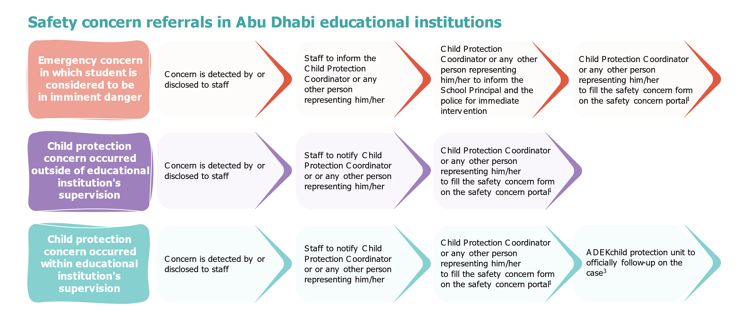

Relevant contact details are as follows:
- Abu Dhabi Police: 999​
- Ministry of Education Child Protection Unit: 80085; cpu@moe.gov.ae (for guidance)
- Family Care Authority: 800444; ICM@adfca.gov.ae ​
- Safety Concern Portal: www.daasafetyconcern.abudhabi

Note: To report or obtain more information on a child protection concern which occurred outside of or within the nursery’s supervision, the Child Protection Coordinator or any other person representing him/her can either call the MoE child protection unit’s hotline number (80085) for all schools and nurseries, or reach out to the MoE child protection unit by email (cpu@moe.gov.ae)

Framework for the initial safety and risk assessment and referrals

As highlighted in the previous section, the ADEK CPU reserves the right to conduct the initial safety and risk assessment, or to designate a qualified nursery personnel to conduct the initial safety and risk assessment. Alternatively, if the concern was referred to the FCA, a Case Manager at the FCA would conduct the initial safety and risk assessment.

Objectives of the initial safety and risk assessment

The initial safety and risk assessment allows the CPS at the ADEK CPU and or the FCA to:
- Determine if there is reasonable cause to believe that a child was maltreated (past harm)
- Determine the current danger for the child (assessment of the child’s safety, current harm)
- Determine the future risk to the child (likelihood of harm occurring to the child in the future)

The initial safety and risk assessment should be completed by the CPS within two hours for emergency concerns, and within 24-48 hours for other concerns.
All child maltreatment concerns that result in the submission of the Safety Concern form, should be subject to an initial safety and risk assessment.
As a result of the initial safety and risk assessment, a determination should be typically made by the CPS as to whether the report is:
- Unsupported – Documented report suggesting why there was no reasonable cause to believe that the child was maltreated, or that the child’s safety or wellbeing was compromised
- Substantiated Concern – Reasonable cause to believe that the child was neglected and the actions or inactions by the perpetrator create the potential for abuse and/or neglect, but there is no immediate danger to the child’s safety or wellbeing; would also include cases where there is reasonable cause to believe that the child is facing harm or risk, with no substantiation
- Supported – Reasonable cause to believe the child was maltreated and the child is at risk; the actions or inactions by the parents/caregivers place the child in danger or pose substantial risk to the child’s safety or wellbeing, or the person was responsible for the child being a victim of sexual exploitation or human trafficking

The levels of risks

Three levels of risk were defined, in addition to the “no risk” level:

Low risk:
- The home is still safe for the child
- The current evidence does not indicate likelihood of serious harm
- The child is potentially at risk if services are not provided to prevent further maltreatment
Recommended intervention timeline: One week

Medium risk:
- The child is likely to suffer some degree of harm without an effective protective intervention plan
- There is limited evidence that the child is at risk of immediate serious injury or death
- The child is currently in the hospital
- The child has been the subject of notifications of concerns in the past two weeks (within or outside the educational setting)
- The child has previously been removed from the care of their family
- The child has siblings that have already been removed from the care of their family
- The child is currently living in a family environment with a known history of drug and alcohol abuse, mental illness, or domestic violence
Recommended intervention timeline: Within 72 hours

High risk:
- There are identifiable indicators of the potential risk of serious harm. The event could happen at any time and the impact would be serious
- The child needs urgent medical attention, is likely to be seriously harmed or injured (incl. self-harm), or subjected to immediate and ongoing sexual abuse, or be permanently disabled, trafficked, or killed if left in their present circumstances without protective intervention
- The child’s physical and health safety are endangered, requiring immediate intervention
Recommended intervention timeline: Immediate

The assessment framework

The framework for the initial safety and risk assessment includes seven dimensions:
- Child’s vulnerability
- Type, severity, and frequency of harm
- History of maltreatment
- Risk of further harm
- Extent of emotional harm
- Source of harm
- Parenting/caregiving skills

The description of the dimensions as well as the criteria to map them to the risk levels are as follows:

It is important to note that these tables are indicative, are by no means comprehensive and should not serve as a checklist for the CPS. The dimensions listed here are all interrelated and can influence and interact with each other. Therefore, it is extremely important that professional judgement be exercised while assessing the level of risk for the child.

It is also important to note that the initial safety and risk assessment is a dynamic process. The situation of the child and family continue to change, and any new information that becomes available should be considered in the re-assessment of the initial safety and risk of the child.
- Child’s vulnerability: Refers to the child’s ability to protect themselves. Factors such as the age of the child (e.g., young children), gender (e.g., girls), and special needs (e.g., disability, developmental issues, mental health issues, chronic illness) can increase the risk of a child of being maltreated. These risk factors also tend to be cumulative: for example, young girls with special needs are at a higher risk of maltreatment.
No Risk | Low Risk | Medium Risk | High Risk
- Children whose needs are met by standard universal services such as access to a general practitioner or nursery support, etc. | - Can take care of and protect themselves  - No special needs | - Requires the support of adult(s) for care and protection  - Mild to moderate special needs | - Completely dependent on adult(s) for care and protection  - Severe special needs

- Type, severity, and frequency of harm: Refers to the number of different types of maltreatment that were identified. For example, for a case of reported neglect, additional types of maltreatment such as emotional or physical abuse could also be identified, resulting in increased risk for the child. Severity relates to the extent of the harm caused (e.g., bodily injury) due to maltreatment. Frequency is a measure of the number of times the child has been maltreated over a given period. As the frequency increases, the risk of harm also increases.

No Risk | Low Risk | Medium Risk | High Risk
- No injury or signs of maltreatment | - Some injury or signs of maltreatment that does not require medical attention  - Occasionally left unsupervised or with unsuitable caregivers | - Significant injury or signs of maltreatment, possibly requiring medical attention  - Pattern of ongoing, infrequent maltreatment  - Occasionally left unsupervised or with unsuitable caregivers | - Severe injury or sexual abuse, most likely requiring urgent medical attention  - Pattern of ongoing, frequent maltreatment  - Occasionally left unsupervised or with unsuitable caregivers

- History of maltreatment: Measures the number of times any concern of maltreatment was reported earlier as well as additional unreported incidents that come to light as a result of the assessment. It is important to note here that lack of previous notifications does not necessarily mean a low level of risk for the child.

No Risk | Low Risk | Medium Risk | High Risk
- No past reports or credible statements to suggest a history of maltreatment | - Isolated incidents of past maltreatment (unreported)  - Unsubstantiated past reports of maltreatment | - Previous substantiated reports of maltreatment (identified as low risk)  - Credible statements of past maltreatment | - Previous substantiated reports of maltreatment (identified as a medium or high risk)  - Credible statements or documentation of past maltreatment

- Risk of further harm: Evaluates the likelihood that the child will be harmed again in the future.

No Risk | Low Risk | Medium Risk | High Risk
- There is unlikely risk of future harm for the child in the future | - There is some risk for the child to be harmed again in the future  - The alleged perpetrator may have caused serious harm in the past, but a repeat of such behavior is not probable | - Considerable risk of future harm  - The alleged perpetrator can cause serious harm if protective factors diminish or fail | - Ongoing harm being cause to the child that will continue in the future

- Extent of emotional harm: Refers to emotional/psychological harm caused due to lack of protection and wellbeing of the child. As a result, the abused child will often demonstrate behavioral concerns and developmental delays, as well as fear of their parent(s)/caregiver(s). While emotional harm may seem like an obvious consequence of all types of maltreatment, it is not always a consequence. Some children may develop resilience and coping mechanisms to deal with the maltreatment that they have been subjected to. On the other hand, emotional harm may not necessarily be caused due to maltreatment.

No Risk | Low Risk | Medium Risk | High Risk
- No emotional/behavioral concerns  - Comfortable living with parent(s)/caregiver(s) | - Minor emotional/behavioral concerns  - Child expresses minor concerns about living with parent(s)/caregiver(s) | - Emotional/behavioral problems, often leading to significant changes in child’s behavior, dress, mannerisms, social relationship, and academic regression and/or developmental delays.  - Child expresses concern or minor fear about living with parent(s)/caregiver(s) | - Extreme emotional/behavioral problems, with serious developmental delays or impaired social functioning  - Child is extremely fearful about living with parent(s)/caregiver(s)

- Source of harm: Measures the ease of access as well as ability of the alleged perpetrator to harm the child. Perpetrators who are related to the child (e.g., parents, siblings, grandparents, uncle), or have relationship with any member of the child’s family (e.g., family friend) have open access to the child and can therefore easily harm them.

No Risk | Low Risk | Medium Risk | High Risk
- The alleged perpetrator has no access to the child | - The alleged perpetrator has access but only when the child is under the supervision of a capable caregiver | - The alleged perpetrator has some unsupervised access of the child  - The alleged perpetrator is a member of the extended family, a family friend, a stranger to the family with some access to the child, etc. | - The alleged perpetrator has unlimited access of the child (for example someone who works at the educational institution)  - The alleged perpetrator lives in the same household as the child (parent/caregiver/sibling/domestic worker/driver/ etc.)

- Parenting/caregiving skills: Evaluates the skills of parents/caregivers that are necessary to take care of their children and ensure their protection. It measures the parents’ overall willingness and ability to protect them. Lack of knowledge and awareness, as well as mental health issues and history of substance/alcohol abuse are some common factors that impair the abilities of parents/caregivers to protect their children. In fact, these risk factors are highly correlated to child/child maltreatment and should therefore constitute high risk during assessment.

No Risk | Low Risk | Medium Risk | High Risk
- Appropriate parenting skills (in line with the child’s developmental needs)  - No mental health issues impairing parental capabilities  - No past/present alcohol and/or substance abuse | - Some gaps in parenting skills  - History of mental health issues with no current problem  - History of alcohol and/or substance abuse with no current problem | - Inconsistency in taking care of the child or moderate gaps in parenting skills  - Some mental health issues, potentially impairing parenting capabilities at times  - Moderate alcohol and/or substance abuse | - Unwillingness or inability to take care of the child  - Serious mental health issues impairing parenting capabilities  - Severe alcohol and/or substance abuse

For example, despite assigning medium risk level to both the type, severity, and frequency of harm, as well as the history of maltreatment, the overall initial and safety assessment may identify it as a high-risk case. In another example, a high risk of child’s vulnerability can be offset by the presence of strong parental support and the child’s resilience, resulting in an overall medium-risk level for the case.

Therefore, all the dimensions should be evaluated for all cases while undertaking the initial safety and risk assessment as the interplay of different factors will influence the determination of the final risk level. Professional judgment should be critically applied to conduct the initial safety and risk assessment, keeping the individual circumstances of the child at the core of the process.

Determining the overall risk level and the subsequent procedures required

Based on the risk assessment, the overall risk should be determined.

This should be mainly determined by the CPS and the designated Case Manager appointed by FCA, using their professional judgement, and making sure that the risk reflects the reality of the situation beyond the assessment analyzed on paper.

If all the dimensions score low, medium, or high then the overall risk level would typically mirror the dimensions or could even be one level higher.

All concerns being assessed as medium or high risk would typically need to undergo the comprehensive Child and Family Assessment, to assess the strengths and needs of the child and their family.

The comprehensive Child and Family Assessment child would be the responsibility of the FCA.

Examples of procedures for concerns detected/disclosed in nurseries by category of reporter

Disclosure from the concerned child

If the child is reporting maltreatment, it is likely that the child has experienced a situation that requires immediate attention.
- The reporter should ensure provision of immediate support, where required in emergency cases (where the child is in imminent danger, by contacting the nearest hospital where required, and/or the Abu Dhabi Police (on 999) depending on the situation)
- Support the child to recount their experience (where appropriate), carefully avoiding any “leading” questions and without communicating (verbally or through body language) any judgement
- If concerns persist, notify the Child Protection Coordinator or any other person representing him/her.
- -Child Protection Coordinator or any person representing him/her to fill in the Safety Concern Form on the safety concern portal. A copy will be automatically sent to the FCA, the ADEK CPU, and MoI CPC. Continue monitoring the situation and provide additional information to the ADEK CPU if needed
- Retain all notes in a secure file – retain notes for the period described under UAE legislations for information handling

Disclosure from parents

- The reporter should ask clarifying questions to better understand the reasons of concern (to the child and parents)
- If concerns persist, notify the Child Protection Coordinator or any other person representing him/her immediately (recommended)
- -Child Protection Coordinator or any person representing him/her to fill in the Safety Concern Form on the safety concern portal. A copy will be automatically sent to the FCA, the ADEK CPU, and MoI CPC. Continue monitoring the situation and provide additional information to the ADEK CPU if needed
- Retain all notes in a secure file – retain notes for the period described under UAE legislations for information handling

Concerns identified by teaching staff

- Where appropriate, ask the child clarifying questions
- If concerns persist, notify the Child Protection Coordinator or any other person representing him/her immediately (recommended)
- Child Protection Coordinator or any person representing him/her to fill in the Safety Concern Form on the safety concern portal. A copy will be automatically sent to the FCA, the ADEK CPU, and MoI CPC. Continue monitoring the situation and provide additional information to the ADEK CPU if needed
- Retain all notes in a secure file – retain notes for the period described under UAE legislations for information handling

Concerns identified by other nursery staff (e.g., nurse)

- Where appropriate, ask the child clarifying questions
- If concerns persist, notify the Child Protection Coordinator or any other person representing him/her.
- Child Protection Coordinator or any person representing him/her to fill in the Safety Concern Form on the safety concern portal. A copy will be automatically sent to the FCA, the ADEK CPU, and MoI CPC. Continue monitoring the situation and provide additional information to the ADEK CPU if needed
- Retain all notes in a secure file – retain notes for the period described under UAE legislations for information handling

Concerns identified by auxiliary nursery staff (e.g., security guard)

- The reporter should notify their immediate supervisor and the Child Protection Coordinator or any other person representing him/her
- In case of reasonable suspicion, work with the Child Protection Coordinator, or any other person representing him/her, to ask the child clarifying questions, and update the form
- Child Protection Coordinator or any person representing him/her to fill in the Safety Concern Form on the safety concern portal. A copy will be automatically sent to the FCA, the ADEK CPU, and MoI CPC. Continue monitoring the situation and provide additional information to the ADEK CPU if needed
- Retain all notes in a secure file – retain notes for the period described under UAE legislations for information handling

Examples of procedures for concerns that would be managed internally by the nursery

All concerns of child maltreatment should be reported to the ADEK CPU.

Where the ADEK CPU, or the FCA, assesses, after the initial assessment, that the concern should be managed within the nursery, then the process would be led by the Child Protection Coordinator or any other person representing him/her within the nursery.

This includes sourcing and filling the below information:
- Part C: Child and Family Assessment to identify the protection needs of the child. This includes evaluating the child’s family situation, risk, and protective factors, as well as understanding if there have been any changes (e.g., developmental, behavioral) observed in the child lately. The Child Protection Coordinator should record other information about the child and their family before deciding what to do about the concerns

Part D: Child Wellbeing Plan by engaging with all relevant stakeholders (e.g., child, parents, nursery counselor). Where appropriate, the participation of the child should be highly encouraged, and they should be informed of the actions being taken at all stages

- Part E: Monitoring and Review of the Safety Wellbeing Plan to ensure proper monitoring of the plan implementation to ensure the child’s wellbeing

All relevant notes and documents should be retained in a secure file.

How should concerns be referred to the Child Protection Unit?

Who to contact for notification of concerns of child maltreatment

- All concerns of student maltreatment should be reported to the Child Protection Coordinator or any other person representing him/her in the nursery
- The Safety Concern Form should be filled by Child Protection Coordinator or any other person representing him/her on the safety concern portal. Once submitted, a copy of the Safety Concern Form will then be automatically shared with the ADEK CPU , with the FCA and the MoI CPC.
- For concerns of maltreatment which occurred under the supervision of the educational institution, the ADEK CPU will review the information first before referring to the FCA for case management, who will take the necessary procedures to follow-up on the cases after receiving the report.

If the child requires medical support, what should be done

- For minor injuries, provide and keep record of medical support at the nursery
- For serious injuries or imminent danger to the child, immediately call an ambulance (on 998) or the Abu Dhabi Police (on 999)
- The mandated reporter should report the concern to the Child Protection Coordinator, or any other person representing him/her if, who then notifies the ADEK CPU via a Safety Concern Form

What forms to fill

Form and Section | Description
Parts B, C, D | Filled for concerns of maltreatment that do not meet the thresholds for reporting to the CPU (i.e., for concerns that will be handled by the nurseries)
The Safety Concern Form | Filled for all concerns of maltreatment detected or disclosed in a nursery

What happens after the concern is reported to the Family Care Authority

- The Safety Concern Form filled and validated by the CPS at the ADEK CPU, along with the initial safety and risk assessment where applicable, would be shared with the FCA (the initial safety and risk assessment for concerns of maltreatment taking place outside the education setting, should be conducted by the FCA)
- A CPS (case manager) from the FCA will be appointed to manage the case
- The Case Manager will review the documentation shared by the CPU (within 24 hours) and will determine whether additional information is needed
- If the case has a criminal aspect, the Abu Dhabi Police would be notified for further investigations (while the FCA continues to manage the case)
- The Family Care Authority Case Manager would then start the process of a comprehensive Child and Family Assessment child (within one week). The FCA case manager would develop a “Child and Family Response Plan”, if needed and ensure the implementation of the plan (by referring the child and family to education and social support services)

How should concerns about nursery personnel be managed

- Any allegation against any nursery personnel should be directly reported to the Child Protection Coordinator or any other person representing him/her.
- Any allegation against the Child Protection Coordinator or any other person representing him/her should be reported to the nursery manager/head teacher or deputy manager/deputy head teachers
- An internal investigation should be initiated on the allegation, and the alleged nursery personnel should be put on administrative leave while the case is under investigation. The investigation would be completed in collaboration with the ADEK CPU
- If the allegation has proved to be true, immediate actions should be taken to report the case to the Abu Dhabi Police, and terminate the employment of the perpetrator
- Strict confidentiality should be maintained at all stages of the internal investigation

Engagement model with the child and family

Dealing with disclosures

Dos on handling disclosures from a child
- Identify a quiet, safe, and comfortable location to talk to the child
- Contain initial reactions by being patient, showing care and concern, listening with undivided attention, and taking the child’s story seriously
- Ensure the child feels safe and supported by responding in a calm way, and reassuring the child that this has happened to others and that they have done the right thing by confiding in you
- Ask open-ended questions to gather more information and clarify the situation (e.g., How did it happen? /What happened?)
- Refrain from asking further questions if the child starts feeling distressed
- Recognize the impact of culture on dealing with disclosures and maintain sensitivity (they may have been threatened not to tell anyone)
- Only record the facts as the child presents them. The notes should not reflect the opinion of the note taker
- Inform the child in an age-appropriate manner that what is happening to them is wrong and you will need to tell someone who can help make it stop
Don’ts on handling disclosures from a child
- Question the story’s validity in front of the child
- Interrupt the child while talking and sharing information
- Pressure the child to respond or to provide details and information against their will
- Promise that you will keep the story as a secret (reporting is mandatory, explaining this is to ensure their safety)
- Promise that things will get better (in some cases it may get worse before getting better)
- Refer to the alleged perpetrator using disparaging comments (it may be someone close to the child)
- Confront the alleged perpetrator and threaten to harm or punish him/her (it may cause more harm to the child)
- Interview other individuals involved in the case (this is done by relevant authorities as part of the investigation)
- Reach out to parents before reporting. Parents’ involvement can have adverse effects such as increase the risk of further maltreatment, force the child to recant the story, withdraw the child from the nursery

How to engage with the family before, during and after notifying a concern

- In cases where the alleged perpetrator is not a family member, the Child Protection Coordinator should inform the family of the notification of the case, the next steps and the support required
- In cases where the child needs to be transferred to a hospital, nursery staff (and Child Protection Coordinator) should contact parents/guardians to inform them of actions being taken but are not obliged to obtain consent from family members if an emergency situation and the child’s wellbeing are at risk
- Engagement with the parents/guardians should be done in a child sensitive manner, catering for their language preferences and should be ideally conducted by the Child Protection Coordinator in the nursery

Confidentiality and information sharing

The ADEK CPU would have a written data protection policy based on the principle of confidentiality to prevent any misuse of information. [Ref: ADEK Private Nurseries Policy & Guidance Manual]

Child Protection Coordinator, members of the Child Protection Team, CPS and other educational institution staff should be aware of the data protection protocols and the security implications of sensitive data.

All educational institution staff are required to protect information related to children involved in the suspicion of child maltreatment and not share it with anyone not directly involved in the care of the child. When information is shared, it should be on a need-to-know basis and limited only to the information necessary to enable better protection of the child.

The ADEK CPU’s Head should update and ensure that data protection protocols are being followed through regular monitoring and mentoring of all staff including CPS, Child Protection Coordinators, and other staff.

  - Record keeping
- Information gathered on children should be allocated a code based on a standard coding format that guarantees anonymity of the child and is used to refer to the child’s case either verbally, on paper or electronically
- Any hard copies of the Safety Concern Form should be kept in a secure place, accessible only to the person responsible for the information
- Rooms containing paper or electronic information should be kept securely locked when the person responsible for the information leaves the room
- Electronic information on children should be password protected, the password changed on a regular basis and be transferred by encrypted or password protected files
- Computers should be fitted with up-to-date anti-virus software to avoid corruption and loss of information

  - Information sharing
- Information sharing with FCA or any other agency (e.g., Abu Dhabi Police, hospitals, etc.) for the purpose of referral should be strictly on a need-to-know basis, and only authorized personnel with clearance should be able to access information
- Information disclosed by children could be shared without consent in exceptional circumstances if it is considered – after careful evaluation – in their best interest to do so, but the reasons for doing so must be clearly explained to them
- The Child Protection Coordinator, members of the Child Protection Team, and other educational institution staff, as well as the CPS in the ADEK CPU sharing information with or any other agency should be open and transparent

Training requirements

All nursery staff (teaching/non-teaching staff and volunteers) should be trained on:
- Child protection practices in the early years
- How to identify signs of maltreatment in children in the early years
- How to actively listen to the child and what age-appropriate clarifying questions to ask the child and how to ask questions
- How and when to engage families
- How to engage with the child following identifying a maltreatment concern
- How to engage with the child when concerns have been validated
- How to report concerns to the Child Protection Coordinator or any other person representing him/her
- Thresholds to report the concern to the CPU vs. resolving the concern within the nursery
- How to address concerns of child maltreatment for children of determination
What information can be shared and what information cannot be shared

Forms needed

Child Protection Safety Concern Form
Initial Safety and Risk Assessment Form

APPENDIX

      - Safety Concern Form

Child Details
Case Reference Number
Full Name | First | second | Third |  | Surname |  |  | Nickname
Nationality | Drop down menu with common nationalities in UAE + Other specify…………………. |  |  |  |  |  |  | Sex | Drop down menu  ❒ Male  ❒ Female
Religion | Drop down menu  ❒ Muslim  ❒ Christian  ❒ Hindu  ❒ Buddhist  ❒ Sikh  ❒ Jew  ❒ Other, please specify …………….. |  |  |  |  |  |  | Age | Drop down menu from 0 to 18  ❒ Is the age estimated?
Religion |  |  |  |  |  |  |  | Date of Birth | Drop down menu  Day\Month\year
Spoken languages | Drop down menu (you can choose more than one)  ❒ Arabic  ❒ English  ❒ French  ❒ Hindi  ❒ Urdu  ❒ Bengali  ❒ Tamil  ❒ Tagalog  ❒ Persian  ❒ Chinese  ❒ Malayalam  ❒ Other, please specify …………….. |  |  |  |  |  |  | Emirates ID number
Spoken languages |  |  |  |  |  |  |  | UID number
Spoken languages |  |  |  |  |  |  |  | If the child has communicative challenges, what is the best means of communication? | Drop down Menu  ❒ Through parents  ❒ Through siblings  ❒ Through family member  ❒ Through teacher  ❒ Through aid  ❒ Through Specialized Center  ❒ Other, please specify…………………………………….
Address (please mention nearest landmarks to address)
Incident details
Date of Incident | Drop down menu  Day\Month\year |  |  |  |  | Time of incident |  |  | Drop down menu  ❒ Morning  ❒ Noon  ❒ Evening  ❒ Night
Place of the Incident? |  |  |  |  |  | Where was the child at the time of the incident? |  |  | Drop down menu  ❒ At home  ❒ At Nursery (drop down menu with  name of all nurseries)  ❒ At School (drop down menu with  name of all schools)  ❒ At Extended Family  ❒ At Neighbors home  ❒ At family friend’s home  ❒ Other, please specify ………….
If in Educational institution what is academic level: | drop down menu  ❒ Nursery  ❒ Grade 1  ❒ Grade 2  ❒ Grade 3  Grades drop down to 12 |  |  |  |  | Suspected type of abuse |  |  | drop down menu, can select more than one option  ❒ Physical Abuse  ❒ Sexual Abuse  ❒ Emotional/Psychological Abuse  ❒ Neglect  ❒ Exploitation  ❒ Bullying/Cyberbullying
If physical or sexual abuse, have the police been contacted? | drop down menu  ❒ Yes  ❒ No |  |  |  |  | If yes, have they initiated any contact yet? |  |  | This question should be skipped if they mark “No”  (drop down menu)  ❒ Yes  ❒ No
Primary Caregiver Details
Name | First | Second | Third | Surname |  | Sex: |  |  | Drop down menu  ❒ Female  ❒ Male
Nationality | Drop down menu with common nationalities in UAE + Other specify…………………. |  |  |  |  | Age |  |  | Drop down menu from 18+  ❒ Is the age estimated?
Religion | Drop down menu  ❒ Muslim  ❒ Christian  ❒ Hindu  ❒ Buddhist  ❒ Sikh  ❒ Jew  ❒ Other, please specify …………….. |  |  |  |  | Date of Birth |  |  | Drop down menu  Day\Month\year
Religion |  |  |  |  |  | Emirates ID number
Religion |  |  |  |  |  | UID number
Relationship to child | Drop down menu  ❒ Mother  ❒ Father  ❒ Grandmother  ❒ Grandfather  ❒ Aunt  ❒ Uncle  ❒ Brother  ❒ Sister  ❒ Other, please specify……………… |  |  |  |  | Does this person live with the child |  |  | Drop down menu  ❒ Yes ❒ No
Relationship to child |  |  |  |  |  | Is this person alive? |  |  | Drop down menu  ❒ Yes ❒ No
Relationship to child |  |  |  |  |  | Is this person the primary caregiver |  |  | Drop down menu  ❒ Yes ❒ No
Relationship to child |  |  |  |  |  | Is this person the offender in this incident? |  |  | Drop down menu  ❒ Yes ❒ No
Spoken Languages | Drop down menu (you can choose more than one)  ❒ Arabic  ❒ English  ❒ French  ❒ Hindi  ❒ Urdu  ❒ Bengali  ❒ Tamil  ❒ Tagalog  ❒ Persian  ❒ Chinese  ❒ Malayalam  ❒ Other, please specify …………….. |  |  |  |  | Does this person have special needs? |  |  | Drop down menu  ❒ Yes ❒ No
Spoken Languages |  |  |  |  |  | If yes, please specify |  |  | ❒ Physical  ❒ Developmental  ❒ Emotional\Behavioral  ❒ Sensory Impairment
Address if different than above child address (please mention nearest landmarks to address) |  |  |  |  |  | Contact Details (phone number, email, etc.)
Alleged Perpetrator (if known)
If the alleged perpetrator is the primary care giver no need to repeat this info)
Name | First | Second | Third | Surname |  | Sex |  |  | Drop down menu  ❒ Female  ❒ Male
Nationality | Drop down menu with common nationalities in UAE + Other specify…………………. |  |  |  |  | Age |  |  | Drop down menu  ❒ Is the age estimated?
Relationship to child | Drop down menu  ❒ Mother  ❒ Father  ❒ Stepmother  ❒ Stepfather  ❒ Grandmother  ❒ Grandfather  ❒ Aunt  ❒ Uncle  ❒ Brother  ❒ Sister  ❒ Other, please specify……………………….. |  |  |  |  | Occupation
Relationship to child |  |  |  |  |  | Contact Details if known (Address, phone number, email, etc.)
Concern Details
Reporting Details Disclosure (please use exact words as relayed by child).
Suspected signs of maltreatment
Observations (if any, incl. date and time) | Drop down menu  ❒ Physical signs/appearance  ❒Behavioral and Emotional signs/actions  ❒ Verbal/communication responses  ❒Other, please specify………….. |  |  |  |  | Please narrate in more detail your observations:
Discussions (if any, incl. date, time, sources)
Does the child have any siblings that may be at risk? | Drop down menu  ❒ Yes  ❒ No |  |  |  |  |  | List any other siblings of the child that may be at risk |  | Drop down menu  - Age:  Sex: ❒ Male ❒ Female  - Age:  Sex: ❒ Male ❒ Female  - Age:  Sex: ❒ Male ❒ Female
Actions taken by mandated Reporter (if any) | Drop down menu\ More than one option can be chosen  ❒ Police have been contacted  ❒ Child has been informed that the concern is being reported  ❒ Non-offending parent has been informed that the concern is being reported  ❒ Offending parent has been informed that the concern is being reported  ❒ Other members of my child protection team have been consulted and aware  the concern is being reported  ❒ Other, please specify………………………………………..
Complainant Details
Name | First | Second | Third |  | Surname | Occupation
Spoken Languages | Drop down menu (you can choose more than one)  ❒ Arabic  ❒ English  ❒ French  ❒ Hindi  ❒ Urdu  ❒ Bengali  ❒ Tamil  ❒ Tagalog  ❒ Persian  ❒ Chinese  ❒ Malayalam  ❒ Other, please specify …………….. |  |  |  |  | Relationship to child |  |  | Drop down menu  ❒ caregiver  ❒ A family member that is not the primary care giver  ❒ friend  ❒ colleague  ❒ neighbor  ❒ No relationship  ❒ unknown  ❒ Other, please specify.......
Work Address |  |  |  |  |  | Contact Details (phone number, email, etc.)
Mandated Reporter Details
Name | First | Second | Third |  | Surname | Emirates ID number
Occupation |  |  |  |  |  | Work Address
Spoken Languages | Drop down menu (you can choose more than one)  ❒ Arabic  ❒ English  ❒ French  ❒ Hindi  ❒ Urdu  ❒ Bengali  ❒ Tamil  ❒ Tagalog  ❒ Persian  ❒ Chinese  ❒ Malayalam  ❒ Other, please specify …………….. |  |  |  |  | Relationship to child |  |  | Drop down menu  ❒ Teacher  ❒ Educational institution staff,  ❒ Doctor  ❒ Psychiatrist  ❒ Psychologist  ❒Others, please specify.......
Contact Details (phone number, email, etc.) |  |  |  |  |  | Who submitted the concern? |  |  | Drop down menu  ❒ CPS from health care  ❒ CPS from Educational  Institution  ❒ CPS from Family Care Authority  ❒ CPS from other entity  ❒ Mandated Reporter
Which Channel was used to submit the concern? | Drop down menu  ❒ FCA Portal  ❒ FCA Email  ❒ FCA call center  ❒ MOI\CPC – Hemayti app.  ❒ MOI\CPC – Portal  ❒ MOI\CPC - Email  ❒ MOI\CPC - Hotline  ❒ MOE Hotline  ❒ Police emergency phone line  999 |  |  |  |  | Permission to use of your information outside the case management system. |  |  | Drop down menu  ❒ Yes  ❒ No
Signature |  |  |  |  |  | Date |  |  | Drop down menu  Day\Month\year

Part B: Referral Decision

Part B: Referral Decision (to be conducted by the Child Protection Coordinator/Child Protection Team based on the information received in Part A and any additional information received from discussion with the reporter)
Action Taken
- Response to be provided in-school
- Case referred to MoE, ESE AND ADEK CPU
- Police notified (in cases where the child is at immediate risk of harm)

The following sections should be completed only for cases that will be managed by the nursery.
Part C: Child and Family Assessment

Part C: Child and Family Assessment (to be filled by the Child Protection Coordinator in coordination with relevant stakeholder, such as, the Child Protection Team, the reporter, the child’s class teacher, etc.)
Information about the child’s family
No. | Name of other adults in the household |  | Age | Gender | Relationship to the child
No. | Name of other children in the household |  | Age | Gender | Enrolled in the same nursery?
Parental risk factors (e.g., mental illness, domestic violence)
Any other risk factors?
Parental protective factors and/or family strengths
Any support service currently in place for the child and/or the family?
Any previous incident of maltreatment of another child in the household?
Any additional observations
Other information about the child’s safety and wellbeing
What is the present situation of the child?
Has the child’s situation changed lately? (e.g., changes in behaviors, academic performance)
Has the child expressed any views or opinions? What were they?

Part D: Child Wellbeing Plan

Part D: Child Wellbeing Plan (to be developed by the Child Protection Coordinator/Child Protection Team in coordination with relevant stakeholders, such as the reporter, the child’s teacher, etc. The child and family, where possible, should be encouraged to participate in the development of the plan)
Issues that require in-nursery response
Educational
Emotional
Behavioral
Relationship
Other
Response plan (to address the issues identified above)
No. | Response action |  |  | Responsible person (name, designation, contact details)
What strengths does the child have that will assist in achieving the plan? (e.g., academic, social, creative)
What challenges does the child face that may get in the way of achieving the plan?
Do all relevant in-nursery staff know about the plan, and their role in implementing the plan?
How will the effectiveness of the plan be measured?
Did the child participate in developing the plan? (If no, why?)
Are the parents aware of the plan and in agreement with it? (If no, why?)

Part E: Monitoring and Review of the Child Wellbeing Plan

Part E: Monitoring and Review of the Child Wellbeing Plan
Issues resolved since last meeting
Issues requiring further actions
Recommendations/ additional remarks
Additional review required? (Please give reasons)
Next review date (if required)

      - Initial Safety and Risk Assessment Form

Case Reference Number
Referring Agency |  |  | FCA Location
Referral Date
Child Details
Full Name |  |  |  | Date of Birth
Nationality |  |  |  | Gender
Preferred Language |  |  |  | Emirates ID Number
Address
Contact Details (phone number, email, etc.)
Special Needs? (If yes, please provide details)

Father’s details
Full Name |  | Date of Birth
Nationality |  | Emirates ID Number
Preferred Languages
Address
Contact Details (phone number, email, etc.)
Special Needs? (If yes, please provide details)
Non-offending Parent?
Primary Caregiver?

Mother’s Details
Full Name |  | Date of Birth
Nationality |  | Emirates ID Number
Preferred Languages
Address
Contact Details (phone number, email, etc.)
Special Needs? (If yes, please provide details)
Non-offending Parent?
Primary Caregiver?
Primary Caregiver’s Details (if different from mother and/or father)
Full Name |  | Date of Birth
Nationality |  | Gender
Emirates ID Number |  | Preferred Languages
Address
Contact Details (phone number, email, etc.)
Special Needs? (If yes, please provide details)

Safety Interventions Taken Already
Interventions taken already to remove threat to the child (e.g., sending the child to the hospital).

Initial Safety and Risk Assessment (this form is for use by the FCA Case Manager, here included for informational purposes)
Dimension |  | Risk level |  |  |  |  |  |  | Please explain your assessment of the risk level
 |  | No Risk |  | Low |  | Medium | High |  | Please explain your assessment of the risk level
Child’s vulnerabilities (e.g., age, gender, special needs)
Type, severity, and frequency of harm
History of maltreatment
Risk of further harm
Extent of emotional harm
Source of harm
Parenting/ caregiving skills
Summary of the Risk Factors

Circumstances, conditions, or events that increase the probability of a child experiencing maltreatment
Summary of the Protective Factors

Protective factor are conditions or attributes in the child and their family as well as the community and the larger society that the child belongs to that mitigate or eliminate risks of child maltreatment, such as, high capacity of parents to meet the needs of the child, healthy relationship between the child and the parent(s).
Overall Risk Level

Based on the above assessment, identify the overall risk level. The decision should be based on the professional judgement of the practitioners and based on the analysis of all risk and protective factors, safety interventions undertaken, as well as any other information known about the case.
 | ⇨ Low |  |  |  | ⇨ Medium |  |  | ⇨ High
 | Briefly explain your observations and reason for selecting the risk level:
Did the child  participate in the Initial Safety and Risk Assessment? (If no, state why)? |  |  | ⇨ Yes  ⇨ No; reason(s): ___________________________________________

Recommended Safety Interventions
- Emergency removal of the child from the home
- Child and Family Comprehensive Assessment required (mandatory for all medium and high-risk cases)
- Case closure, referral of the child and/or family to support services

- Case closure, no further action required (notify the child and the family that no action will be taken)

- Other, please specify: _______________________________________________________________________________

Safety Plan
Safety Intervention | Actions Required | Responsibility | Timeframe
Please provide additional information on the safety intervention and/or safety plan:

Additional notes from the Case Supervisor and/ or the Case Manager (if any):

Name of Case Manager |  |  |  | Signature | Date
Name of Case Supervisor |  |  |  | Signature | Date

List of Policies to be Referenced:

- Abu Dhabi Child Protection Policy
- MoE National Bullying Prevention Policy
- MoE Cyberbullying Policy
- MoE National Policy on Child Protection in Educational Institutions in the United Arab Emirates
- ADEK Private Schools Policy and Guidance Manual (under revision)
- ADEK Private School Reopening Policies (2021)
- Abu Dhabi Student Protection Policy 2022
- ADEK School Staffing Policy
- ADEK Policy on Staff CPD/Licensing
- ADEK Policy on School Reports & Other Documents
- Link to ADEK Child Protection Compliance Framework

List of Systems to be Referenced:

- ADEK ESIS System
- ESE Student Information System
- MoE Student Information System

⁾ Time recommendations can be obtained from WHO recommended guidelines or those shared by mandated agencies within the UAE.
As per the United Nations, youth include 15-24 age groups.
⁾ According to the UAE Labor Law, juvenile work permits can be granted for individuals between the ages of 15 and 18, under several conditions.
As per the Interagency Working Group on Sexual Exploitation of Children, “Child sexual abuse material” or “child sexual exploitation material” are now preferred alternatives to the term “child pornography”.
Outlined in detail on page 32 of this document
A similar training course is being made available for nursery, KG, and nursery staff as well

